



**Module Code & Title**

CS6P05 Final Year Project MAD

**FitGuide Pro** –Mobile App

**Assessment Weightage & Type**

60% Final Coursework

**Module Leader By**

Mr. Subin Chitrakar

**Student Details**

Name: Sita Ram Thing

London Met Id: 22015892

College Id: NP01MA4S220003

Islington College, Kathmandu

17 Jan 2024

**Figma:** https://www.figma.com/file/PjjW3Pp8AsMEoduqnlcQnQ/Interaction-Design?type=design&node-id=0%3A1&mode=design&t=8NcKNZYPM5QQbJ2w-1

**FigJam:** https://www.figma.com/file/VqDnF8hpYm37PbQqmMXF2E/Empathy-Map?type=whiteboard&node-id=0%3A1&t=peXHtqLUmH6cGEQU-1

**Table of Contents**

1. Introduction 1

2. Empathies 3

2.1 Identify Users 3

2.1.1. Fitness Beginners 3

2.1.2. Advanced Enthusiasts 3

2.1.3. Time-Conscious Individuals 3

2.1.4. Health-Conscious Users 3

2.1.5. Community Seekers 3

2.1.6. Tech-Savvy Users 4

2.1.7. Goal-Oriented Users 4

2.2 Interview/Survey 4

2.2.1. Interview No 1 (Sangam Shrestha) 4

2.2.3. Interview No 2 (Pradesh Sapkota) 6

2.3 Empathy Map 8

2.4 User Persona 9

2.5 User Journey Map 10

2.5 Problem Identification 10

2.5.1. Time Constraints and Health Maintenance: 10

2.5.2. Need for Simplification and Guidance: 10

2.5.3. Balancing Work and Relaxation: 11

2.5.4. Technology Integration: 11

2.5.5. Physical and Mental Well-being: 11

2.5.6. Sleep-related Issues and Fatigue: 11

2.5.7. Nutrition and Exercise Priorities: 11

3. Define 13

3.1 Problem Statement 13

3.2 Problem Needs 13

3.2.1. Time-efficient Solutions: 13

3.2.2. Comprehensive Health Guidance: 13

3.2.3. Technology Integration for Health: 13

3.2.4. Work-Life Balance Support: 14

3.2.5. Knowledge Enhancement: 14

3.3 Scope of Project 14

3.3.1. Functional Specification 14

3.3.2. Content Specification 15

3.4 User Goals and Objectives 23

4. Ideate 25

4.1 Competition Review 25

4.2 Storyboard (User flow) 27

5. Prototype 29

5.1 Wireframe 29

5.2 Low fidelity 31

5.3 High-fidelity 35

6. Test 39

6.1 UI Design Testing 39

6.2 UX Testing 39

6.3 Prototype Testing 39

6.4 Functional Testing 39

7. Conclusion 40

References 41

Appendix 42

**List of Table**

Table 1: UI testing 39

Table 2: UX testing 40

Table 3: Functional test 41

**List of Features**

Figure 1: Empathy map 8

Figure 2: User persona Sangam Shrestha 9

Figure 3: User persona Pradesh Sapkota 9

Figure 4: User Journey map 10

Figure 5: Image content specification in splash and walkthrough screen 18

Figure 6: Image content specification in the overall dashboard screen 19

Figure 7: Image content specification in the category items screen 20

Figure 8: Color selected from Fuzzy math. 21

Figure 9: Color code is taken from the colour hunt 22

Figure 10: FitWell Plus 25

Figure 11: User flow category screen 27

Figure 12: User flow home notification screen 27

Figure 13: User flow login screen 28

Figure 14: User flow walkthrough screen 28

Figure 15: Wireframe walkthrough, login and home screen 29

Figure 16: Wireframe category, contact and profile screen 30

Figure 17: Low-Fidelity walkthrough screen 31

Figure 18: Low-Fidelity Login screen 32

Figure 19: Low-Fidelity user update screen 32

Figure 20: Low-fidelity home and notification screen 33

Figure 21: Low-Fidelity Category screen 33

Figure 22: Low-Fidelity Contact screen 34

Figure 23: Low-Fidelity Profile screen 34

Figure 24: High-fidelity walkthrough screen 35

Figure 25: High-fidelity user update screen 36

Figure 26: High-Fidelity profile screen 36

Figure 27: High-Fidelity login screen 37

Figure 28: High-fidelity home & notification screen 37

Figure 29: High-Fidelity contact screen 38

Figure 30: High-Fidelity category screen 38

# Introduction

HFE stands at the forefront of fitness education, recognized as a leading provider of Fitness Courses, Training, and Qualifications in the United Kingdom. Our commitment to excellence is evident in the comprehensive programs we offer, covering various disciplines such as personal training, group exercise instruction, yoga, Pilates, nutrition, and more. With a rich history of delivering high-quality education, HFE has become synonymous with excellence in the dynamic field of fitness. Operating in the UK, HFE is dedicated to shaping the future of fitness professionals and enthusiasts alike. Our industry-recognized qualifications are a testament to the standards we uphold, ensuring that individuals are well-equipped for success in the ever-evolving fitness industry.

HFE takes pride in offering a comprehensive range of fitness courses, training programs, and industry-recognized qualifications. Whether you aspire to become a certified fitness instructor or personal trainer or wish to specialize in areas like yoga or nutrition, HFE provides the knowledge, skills, and accreditation necessary for success in the dynamic fitness industry. HFE is a genuine and reputable company operating in the United Kingdom. Our track record speaks for itself, as we consistently deliver high-quality fitness education and training to individuals across the country. With a steadfast commitment to excellence, HFE is recognized as a trustworthy resource for those seeking professional qualifications in the fitness sector.

In the era of digital convenience, HFE is excited to announce the development of a groundbreaking mobile application, "Fitguide Pro," designed to enhance the learning experience for fitness enthusiasts at all levels. This innovative app serves as an indispensable companion, granting users on-the-go access to a wealth of course materials, study resources, and interactive tools. Fitguide Pro features a range of engaging elements, including video tutorials, insightful quizzes, and seamless communication channels with knowledgeable tutors, providing a comprehensive platform for individuals to enrich their fitness education journey with HFE.

Fitguide Pro is not only tailored for seasoned fitness enthusiasts but also extends its support to beginners, offering valuable insights, customizable workout plans, and fostering a supportive community. With a commitment to streamlining the fitness education journey, this app is poised to revolutionize the way individuals approach their fitness goals. Fitguide Pro aims to make education, guidance, and progress tracking readily accessible at users' fingertips, empowering them to embark on and sustain their fitness endeavours with confidence and success. Stay tuned for an immersive learning experience that goes beyond traditional boundaries.

# Empathies

## Identify Users

Empathizing with users is crucial for the success of a fitness app. Understanding the diverse needs and preferences of users allows the app to provide a more personalized and engaging experience. Here are some key user segments to consider:

### 2.1.1. Fitness Beginners

Users who are new to fitness and need guidance on getting started. Tailor content to include beginner-friendly workouts and educational resources to build foundational knowledge.

### 2.1.2. Advanced Enthusiasts

Users with a higher fitness level seek challenging workouts and advanced training programs. Provide advanced exercises, specialized training routines, and opportunities to set and achieve ambitious fitness goals.

### 2.1.3. Time-Conscious Individuals

Users with busy schedules looking for quick and effective workout routines.

Offer short and focused workout sessions that can easily fit into their daily routines.

### 2.1.4. Health-Conscious Users

Users with specific health goals, such as weight management or stress reduction. Incorporate nutrition tracking, mindfulness exercises, and content focused on holistic well-being.

### 2.1.5. Community Seekers

Users who thrive on social interaction and group activities. Integrate social features, challenges, and forums to foster a sense of community and support.

### 2.1.6. Tech-Savvy Users

Users who appreciate cutting-edge technology and integration with wearables. Ensure compatibility with fitness trackers, smartwatches, and other tech gadgets to enhance their experience.

### 2.1.7. Goal-Oriented Users

Users with specific fitness goals, such as weight loss, muscle gain, or flexibility improvement. Offer personalized workout plans and progress-tracking features to help them stay focused on their objectives.

By identifying and empathizing with these user segments, a fitness app can tailor its features and content to better meet the diverse needs and preferences of its audience, ultimately enhancing user satisfaction and engagement.

## Interview/Survey

### 2.2.1. Interview No 1 (Sangam Shrestha)

The Sangam is a person who works in the TI company as a QA.

1. What's a typical day like at your home? Are there physical activities involved?

* A typical day at home involves regular chores like cooking and cleaning. Sometimes I do some light exercises or go for a walk in the evening.

1. Have you tried making your daily tasks simpler or more efficient?

* Yes, I try to find easier ways to finish my tasks faster, like organizing my schedule or using helpful social media.

1. How do you usually spend your free time or holidays?

* During my free time or holidays, I enjoy relaxing with family, watching movies, playing badminton, or reading books.

1. What are the major challenges in your job, and how do you manage your time to handle them?

* In my job, meeting deadlines and many times some things testing can be challenging. I manage time by prioritising tasks and staying organised.

1. Do you do anything specific to stay healthy during busy periods? How do you relax and clear your mind?

* I try to eat well and take short breaks to stretch or meditate during busy periods. Relaxing music helps me unwind.

1. What do you think about your health? Do you have any concerns, and why?

* I think I'm healthy, but I sometimes worry about maintaining a balanced lifestyle.

1. How do you feel about new technologies or innovations for health?

* New technologies and innovations are exciting, especially if they simplify daily life or enhance productivity but have no ideas for any health-related information.

1. What do you look for in physical activities that you find helpful or enjoyable?

* I prefer physical activities that are fun yet beneficial, like cycling or playing sports.

1. Can you remember a recent time when it was hard to maintain a healthy lifestyle?

* There was a time when work demanded a lot, making it tough to stick to a healthy routine.

1. Do you have any wish existed to make health-related tasks easier for you?

* It would be great to have an app that suggests quick and healthy meal options based on a busy schedule.

1. What do you want to need for physical feeds on your health?

* For my physical health, I need nutritious meals and some form of exercise regularly to stay active and fit.

### 2.2.3. Interview No 2 (Pradesh Sapkota)

The Pradesh Sapkota is a person who works in Food delivery.

1. How do you manage the work and exercise during your free day, and how many times do you walk or run for at least minutes per day?

* On Saturday I have full free time but on other days morning time I physically exercise then in the evening time join the gym training center for 2 hours where walking and running for around 45 minutes per day.

1. How many hours of sleep are you getting on average each night?

* I sleep around 7 hours from 11 PM to 6 AM.

1. Do you consume a balanced diet with a variety of fruits, vegetables, lean proteins, and whole grains?

* Yes, I maintain a balanced diet by including a variety of fresh fruits and different food items daily.

1. Are you staying every day feeling physically healthy by doing enough of your work throughout the day?

* No, I often feel fatigued from my work and recognize the importance of incorporating rest and better time management into my daily routine to maintain physical well-being.

1. Do you take breaks from sedentary activities, such as working at a desk or watching TV, managing stress through techniques like mindfulness, meditation, or relaxation exercises, and performing flexibility exercises, such as stretching or yoga or anything more?

* Yes, I do take breaks from sedentary activities and incorporate stress management techniques and flexibility exercises. However, I lack sufficient knowledge about how to maintain physical fitness.

1. Would you consider joining a training or fitness-related knowledge application to enhance your physical fitness, based on your current priorities and time management for exercise in your daily or weekly schedule?

* Yes, considering my current priorities and time constraints, joining a training or fitness-related knowledge seems like a practical choice to enhance my physical fitness.

1. What do you need for your physical fitness to maintain a healthy life?

* I need effective food-eating management, entertainment, and adherence to fitness guidelines, Yoga, or other physical activity.

## Empathy Map

An empathy map is a visual tool used in design thinking and user experience (UX) design to understand and empathize with the experiences, thoughts, and emotions of a target user or persona. It helps design teams gain deeper insights into the user's perspective, fostering a more user-centred and empathetic approach to creating products or services. The empathy map is generated by interviews to collect the key points of user thinking, saying, doing, feeling, pain and gains. The two different fields users can take the interview where the first one is IT field and other field are Hotel Management field. (Group, 2024)

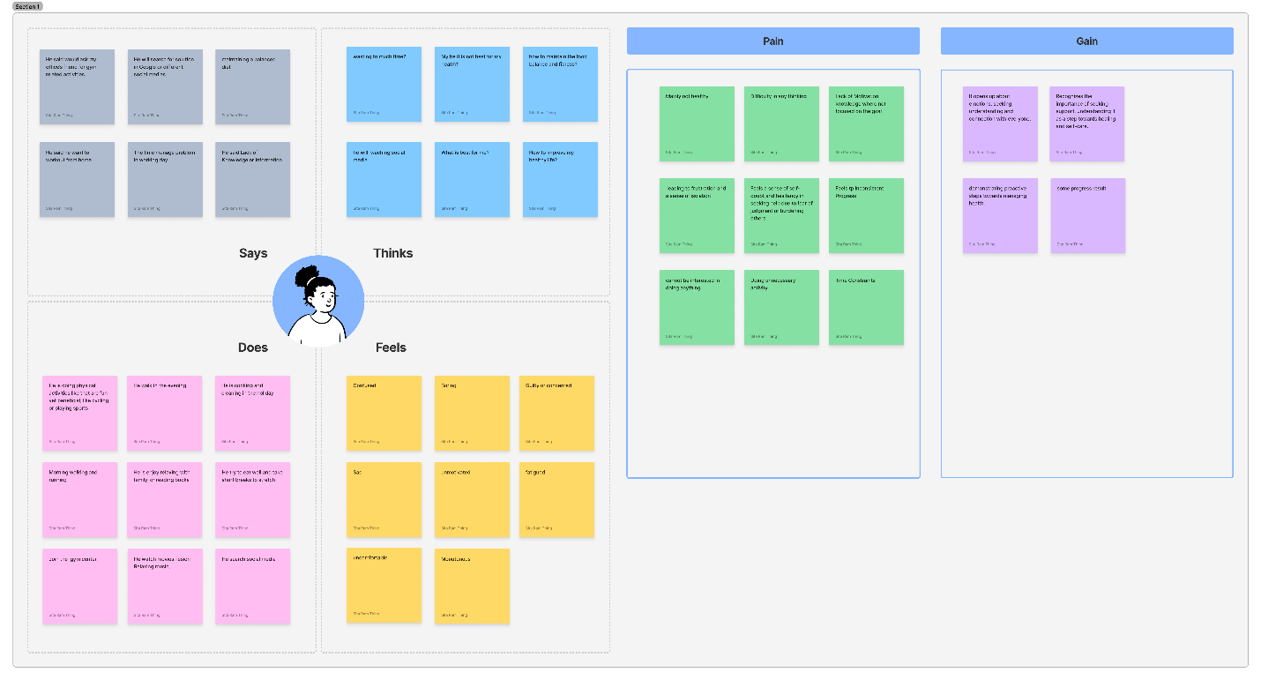

Figure 1: Empathy map

## User Persona

A user persona is a detailed and fictional representation of a typical user within a specific target audience. It is a powerful tool used in design and marketing to humanize and understand the needs, goals, behaviours, and preferences of the target users. By creating a user persona, design teams can make more informed decisions, ensuring that the product aligns closely with the expectations and experiences of the intended users. The process of creating a user persona involves gathering and synthesizing data from user research, interviews, and other relevant sources. (Edwards, 2024)

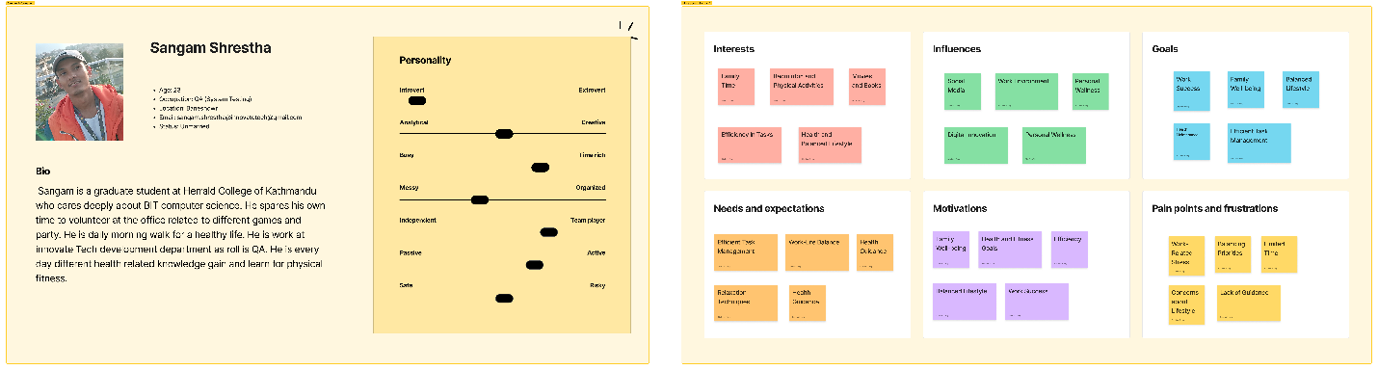

Figure 2: User persona Sangam Shrestha

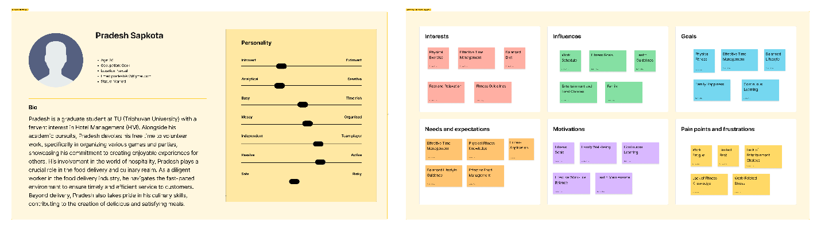

Figure 3: User persona Pradesh Sapkota

## 2.5 User Journey Map

The route a person takes to go from being generally aware to becoming a potential customer to being a brand devotee is known as the customer journey. A visual representation of this path across all the interactions, or touchpoints, a consumer will have with a business is called a customer journey map. This user journey map provides insights into the experiences, needs, and aspirations of individuals balancing work commitments and health priorities, reflecting a diverse range of daily routines and approaches to well-being. (Pell, 2024)

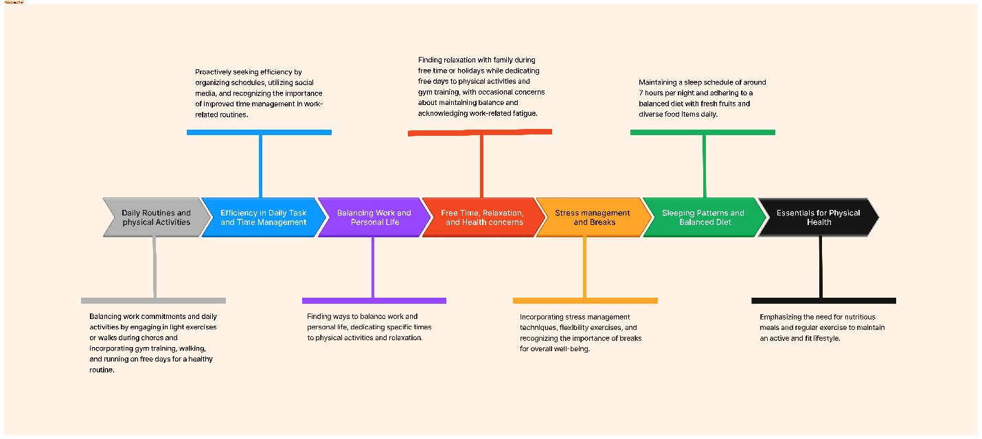

Figure 4: User Journey map

## Problem Identification

### 2.5.1. Time Constraints and Health Maintenance:

Respondents face challenges in managing time between work, chores, and maintaining a healthy lifestyle. Struggling to stick to a healthy routine during demanding work periods impacts overall well-being.

### 2.5.2. Need for Simplification and Guidance:

Expressing a desire for an app that suggests quick and healthy meal options indicates a need for simplifying health-related tasks. Lack of sufficient knowledge about maintaining physical fitness highlights the need for guidance and education.

### 2.5.3. Balancing Work and Relaxation:

Challenges in balancing work commitments and relaxation emphasize the importance of breaks, stretching, and meditation during busy periods.

### 2.5.4. Technology Integration:

Openness to new technologies and innovations for health creates an opportunity for tech-based solutions to enhance well-being.

### 2.5.5. Physical and Mental Well-being:

Concerns about maintaining a balanced lifestyle indicate a connection between physical and mental well-being, suggesting a holistic approach is needed.

### 2.5.6. Sleep-related Issues and Fatigue:

Acknowledgement of feeling fatigued from work highlights the importance of addressing sleep-related issues and managing fatigue for overall health.

### 2.5.7. Nutrition and Exercise Priorities:

Prioritization of nutritious meals and regular exercise signals the need for solutions that align with these priorities.

The identified problems revolve around time constraints, the need for simplification and guidance, balancing work and relaxation, technology integration, the interconnectedness of physical and mental well-being, sleep-related issues, and the importance of nutrition and exercise. Solutions should address these key points to improve the overall health and well-being of individuals in similar situations.

# Define

## Problem Statement

In the current lifestyle, individuals face challenges balancing work responsibilities and maintaining a healthy routine. The hectic nature of work often leads to fatigue, making it difficult to adhere to wellness practices consistently. While efforts are made to simplify daily tasks and incorporate physical activities, there's a need for comprehensive solutions addressing time management, stress reduction, and guidance on maintaining physical fitness during busy periods. The multifaceted challenges identified, including time constraints, the need for simplification and guidance, work-life balance, technology integration, the interconnectedness of physical and mental well-being, sleep-related issues, and nutrition and exercise priorities, collectively form the crux of the problem. Addressing these challenges comprehensively will contribute to the development of effective solutions that significantly improve the overall health and well-being of individuals facing similar circumstances.

## Problem Needs

### 3.2.1. Time-efficient Solutions:

There's a need for strategies that simplify daily tasks and enhance efficiency to create more time for health-focused activities.

### 3.2.2. Comprehensive Health Guidance:

Individuals seek guidance on maintaining a healthy lifestyle, including nutrition advice, exercise routines, and stress management techniques.

### 3.2.3. Technology Integration for Health:

The desire for innovative solutions, like a health app, indicates a need for technology-driven tools that provide quick, personalized, and practical health-related information.

### 3.2.4. Work-Life Balance Support:

Balancing work commitments and personal well-being requires support systems that promote breaks, relaxation, and effective time management.

### 3.2.5. Knowledge Enhancement:

Individuals express a lack of knowledge about maintaining physical fitness, highlighting a need for educational resources and training applications.

## Scope of Project

### 3.3.1. Functional Specification

A) Splash Screen: Display an engaging splash screen while the app initializes. Transition to the main interface after a brief period.

B) Onboarding Screens: Present users with onboarding screens to introduce them to the app's features. Include navigation options like skip, back, and next.

* OTP verification:

Provide a secure login system. Include options for phone number login authentication with opt verification.

C) Dashboard: After login, users land on a dashboard. Display personalized information, such as recent activities, achievements, and a quick overview of fitness metrics.

* Fitness Tracking:

implement a feature for users to log and track their daily workouts. Allow users to input details like exercise type, duration, and intensity.

* Workout Plans:

Provide pre-built workout plans for various fitness levels and goals. Allow users to customize or create their workout plans.

* Video Tutorials:

Include a library of video tutorials for different exercises. Users can access guided workouts for proper form and technique.

* Progress Tracking:

Enable users to track their fitness progress over time. Graphs and charts can visually represent improvements in strength, endurance, or weight loss.

* Challenges and Competitions:

Include challenges or competitions to encourage friendly competition among users. Provide rewards or badges for completing challenges.

* Contact Feedback and Support:

Provide a section for users to submit feedback. Include customer support features such as email support.

### 3.3.2. Content Specification

A content specification is a detailed document that outlines the structure, elements, and requirements for the content within a particular project. It serves as a guide for content creators, designers, developers, and other stakeholders involved in the project, ensuring a consistent and cohesive approach to content creation. This involves providing a general overview or framework for how the content will be organized. where the design process time has got the references for different web pages like with colour, font, design process style, theming and more.

In the context of software development or web design, a content specification typically includes details about text, images, multimedia, and other elements that will be present in the final product. Here are some key components often found in a content specification:

1. Typography:
   * Font style: Sane serif
   * Font: Bold, Regular, Normal
   * Typeface: Satoshi Variable
   * Font size: 12: Caption, Date,
     + 14: Input text field value, Paragraph (Normal), small button text
     + 16: Bold Text, Headline, Medium Button Text
     + 18: Large button text,
     + 28: Subheading,
     + 24: Main Heading
2. Text Content:

During both the low and high-fidelity design phases of a project, designers often seek inspiration by referencing text content from various websites. This process aids in the development of a more dynamic and engaging user interface. By incorporating different textual styles and structures, designers can experiment with diverse approaches, ensuring the eventual choice of text components aligns seamlessly with the overall design aesthetic. The text references are given below:

* walkthrough screen
* Elevate your fitness journey with expert guidance and dynamic workouts.
* Elevate your fitness journey with expert guidance and dynamic workouts.
* Notification details screen
* Embark on a transformative journey with ancient Taoist wisdom, weaving vibrant colours into your well-being. Seek balance through serene blues and greens, detoxify with pure white light, invigorate vitality with earthly reds, radiate nourishment in a golden glow, and unfold purification through regal purples. (Johansson, 2024)

Category Items Screen

* Trikonasana, Matsyasana, Yogasanas, Yogasanas, Vriksasana, Emotions and acidity, Bhujangasana, Paschimottanasana (Finder, 2024)

1. Images and Multimedia:

Throughout the stages of low and high-fidelity design, the integration of images and multimedia plays a pivotal role. Designers draw inspiration from various websites to explore diverse visual elements, ensuring a rich and visually compelling user experience. By referencing different sources for images, videos, and other multimedia components, designers can experiment with styles, formats, and placements, ultimately contributing to a more engaging and aesthetically pleasing design.

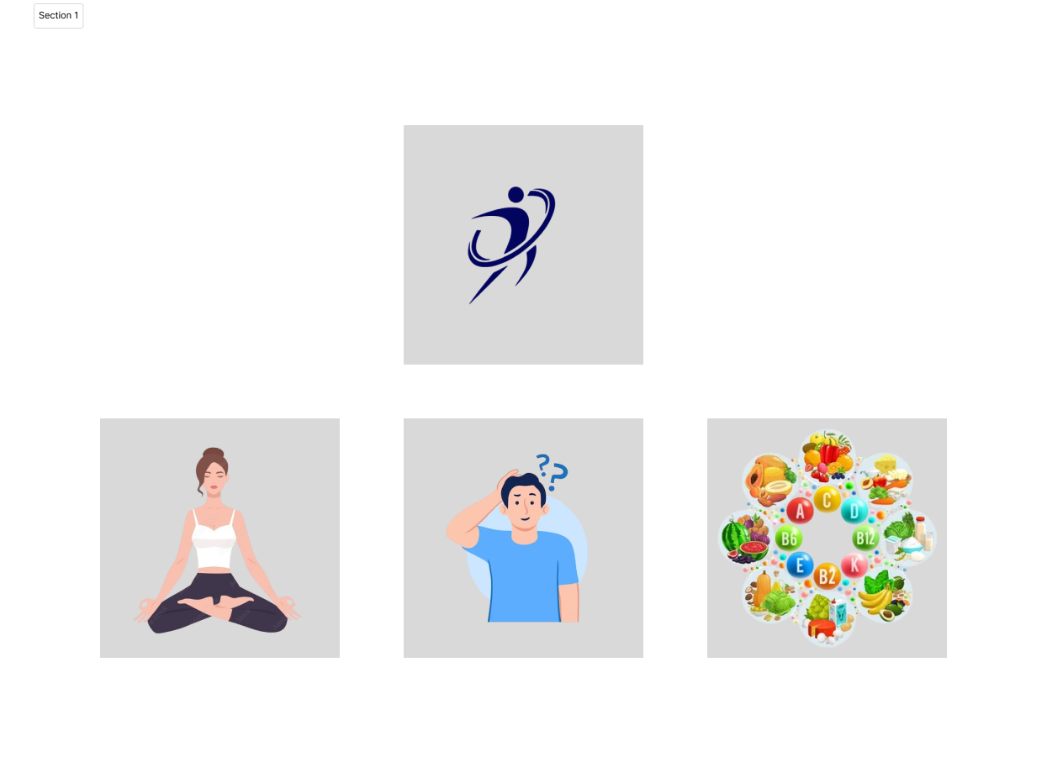

Figure 5: Image content specification in splash and walkthrough screen

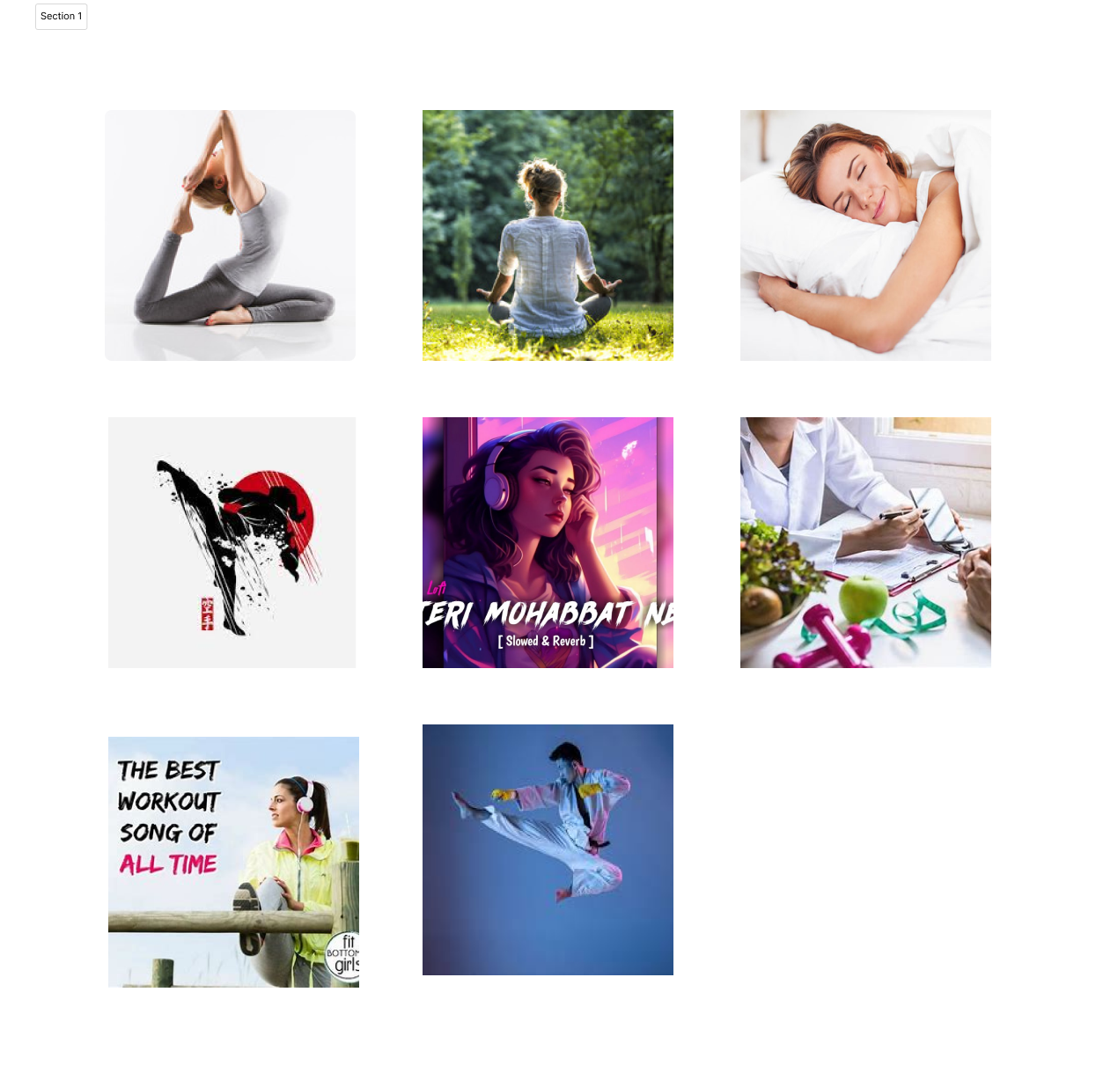

Figure 6: Image content specification in the overall dashboard screen

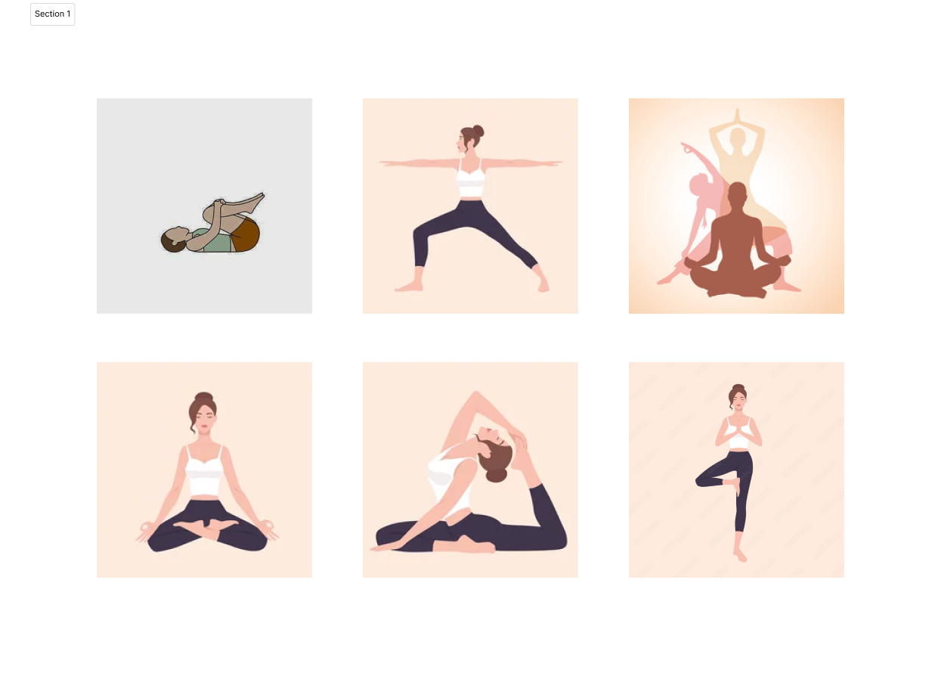

Figure 7: Image content specification in the category items screen

Go to the Appendix

C) Color:

In the iterative process of low and high-fidelity design, the selection of colour schemes becomes a key focus. Designers often draw inspiration from different websites to explore diverse colour palettes, ensuring a harmonious and visually appealing interface. Additionally, attention is given to other design elements such as typography, iconography, and overall visual hierarchy. By referencing various sources, designers can experiment with combinations that not only align with the brand's identity but also contribute to a cohesive and vibrant user experience.

* Color finalizes from Fuzzy math (Sevareid, 2024)

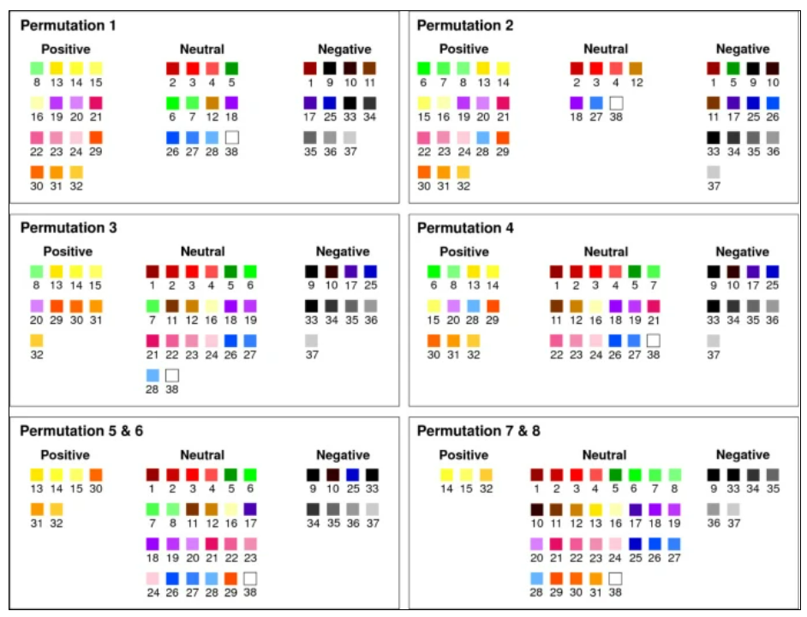

Figure 8: Color selected from Fuzzy math.

* Color code taken from color Hunt (Hunt, 2024)

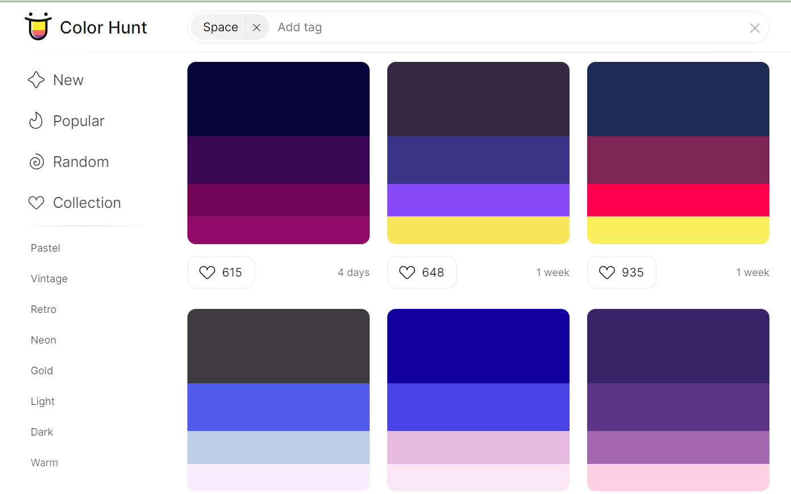

Figure 9: Color code is taken from the colour hunt

## User Goals and Objectives

The main aim is to empower users with a holistic approach to health by providing personalized fitness plans, balanced nutrition guidance, diverse workout videos, and mindfulness activities for improved physical and mental well-being.

The objective of the FitGuide Por application features is given below:

* Users should be able to set and track personalized fitness goals, such as weight loss, muscle gain, or cardiovascular improvement.
* Provide a variety of workout routines that cater to different fitness levels and can be performed at home or in a gym, ensuring flexibility and convenience.
* Allow users to input their fitness levels, preferences, and any health restrictions to generate customized workout plans that align with their goals.
* Implement features for users to log their daily activities, track workout performance, monitor nutrition, and visualize progress over time through charts and graphs.
* Integrate motivational features, such as achievement badges, personalized challenges, and reminders to keep users engaged and committed to their fitness routines.
* Enable seamless integration with popular fitness trackers and wearables to automatically sync data, such as steps taken, heart rate, and sleep patterns, for a more comprehensive view of users' overall health.
* Offer informative articles, videos, and tutorials on fitness, nutrition, and general well-being to empower users with knowledge that can enhance their understanding of healthy living.
* Design for an easy-to-navigate user interface that accommodates users of all technological proficiency levels, making the app accessible and enjoyable for a broad audience.
* Continuously improve the by providing regular updates, incorporating user feedback, and introducing new features to keep the platform dynamic and in line with evolving fitness trends and technologies.

1. Ideate

## **Competition Review**

One similar app in the fitness landscape are "FitWell Plus", and “Fresh Tri”. FitWell Plus provides a comprehensive solution for users seeking physical fitness and mental well-being. The app offers a variety of workout routines, nutrition tracking, and mindfulness exercises. Users can customize their fitness plans based on personal preferences and health goals, and the app provides real-time progress tracking to keep users motivated.

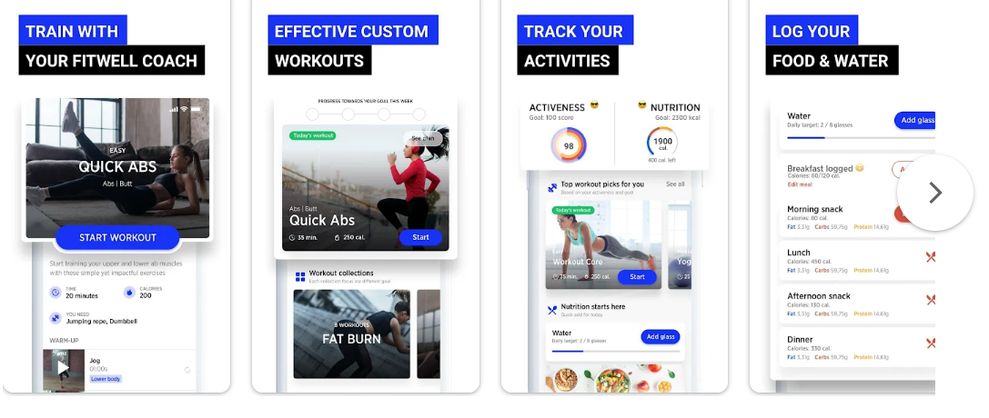

Figure 10: FitWell Plus

FitGuide Pro and FitWell Plus share similarities in their offerings, and FitGuide Pro distinguishes itself in a few key aspects. FitGuide Pro places a strong emphasis on a user-centric design process, incorporating in-depth research, including user interviews, empathy mapping, and persona development. This ensures that the app is finely tuned to meet the specific needs and preferences of its users. FitGuide Pro stands out with its integration of real-time collaboration features through FigJam. This facilitates effective teamwork and seamless brainstorming sessions during the design phase, contributing to a more dynamic and engaging user experience. Furthermore, FitGuide Pro sets itself apart by providing a more extensive educational component. In addition to guiding users through workouts, the app offers a wealth of fitness knowledge, nutritional guidance, and mental well-being practices. This educational focus distinguishes FitGuide Pro as a holistic resource for users looking to not only improve their physical fitness but also enhance their overall health and well-being.

## Storyboard (User flow)

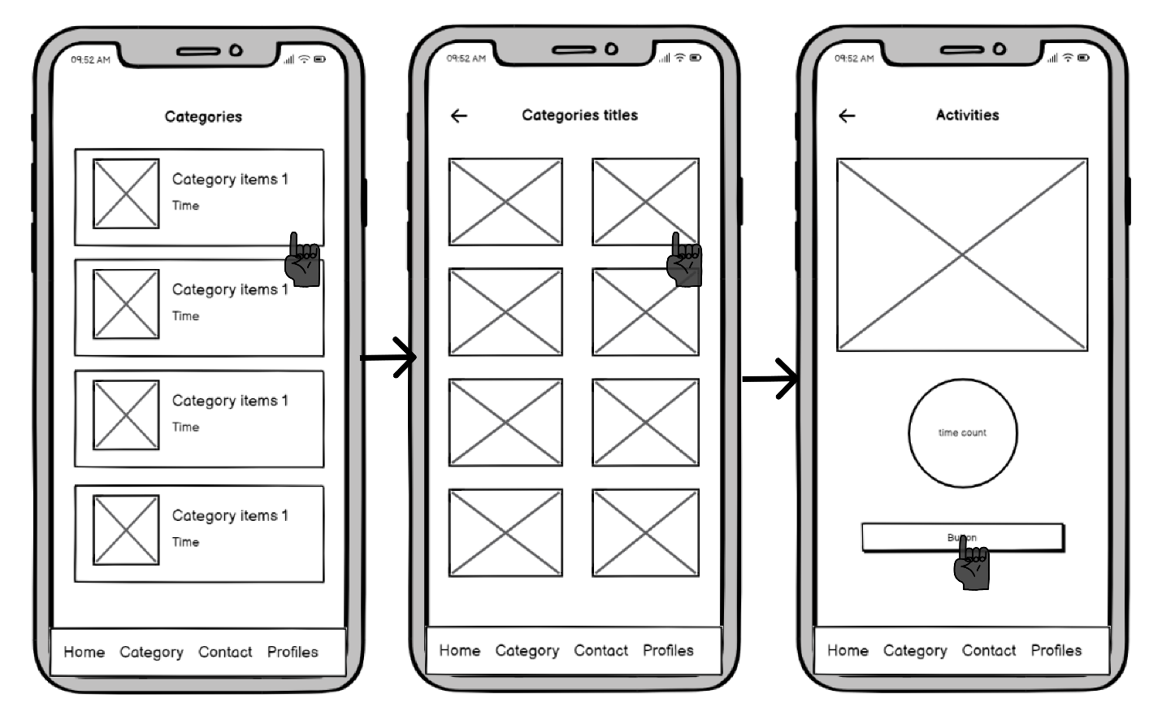

Figure 11: User flow category screen

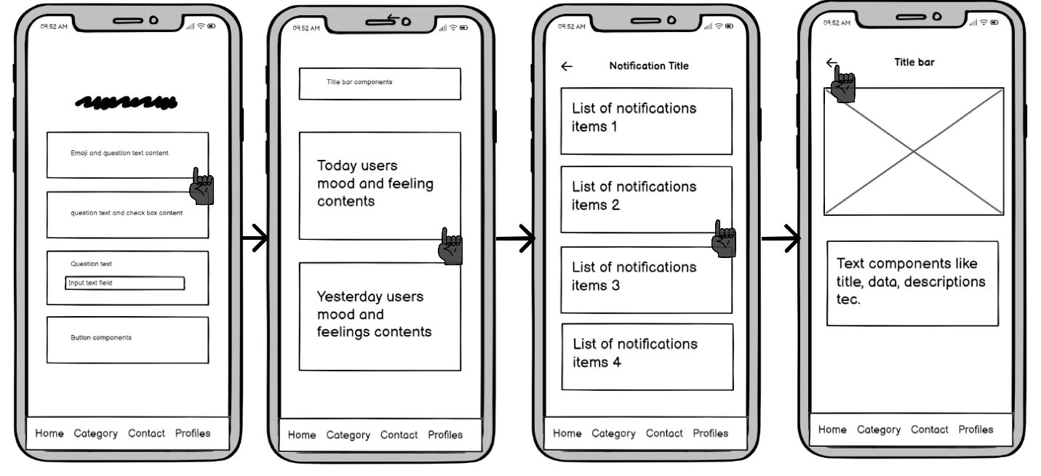

Figure 12: User flow home notification screen

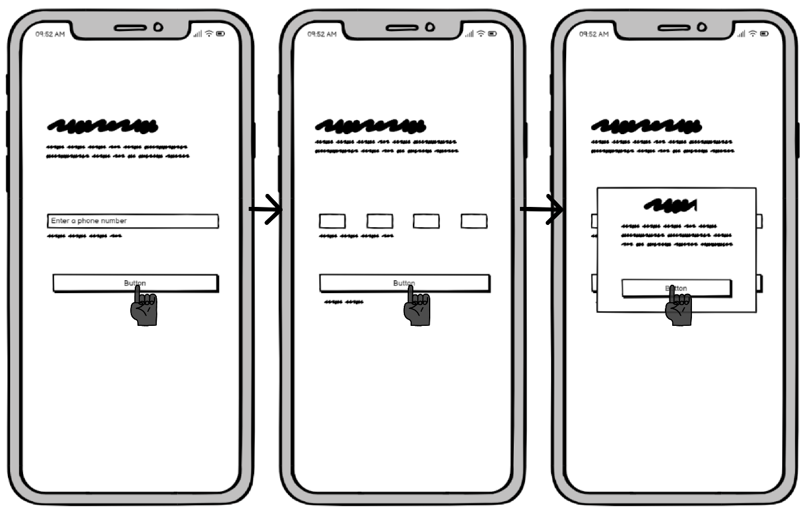

Figure 13: User flow login screen

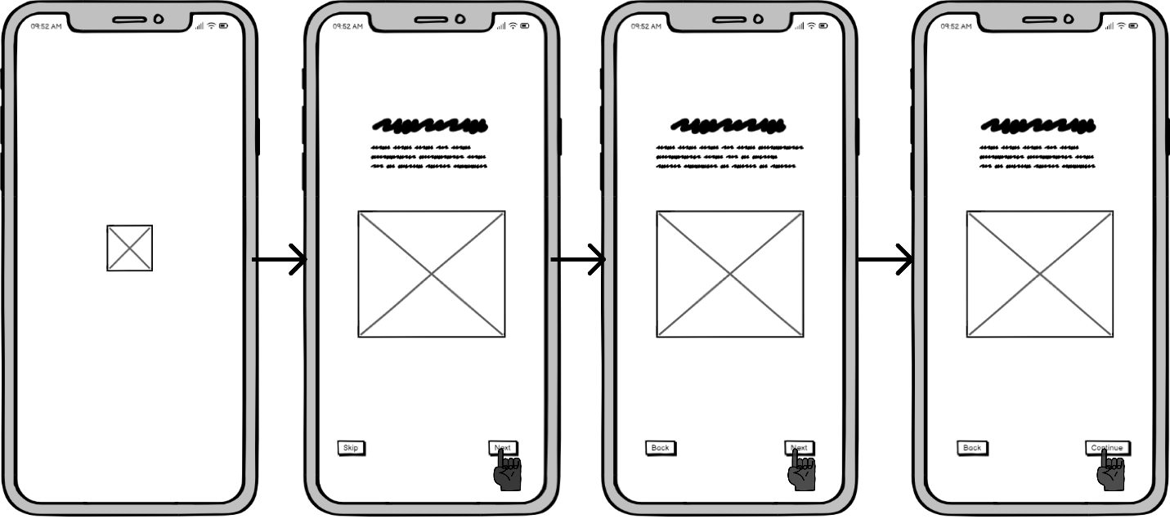

Figure 14: User flow walkthrough screen

1. Prototype

## Wireframe

A wireframe is a diagram or blueprint that helps facilitate communication and thought processes among you, your programmers, and your designers regarding the organization of the software or website you are developing. The wireframe design captures the essence of a user interface with simplicity and clarity. The clean and low-fidelity visuals allow for rapid prototyping, focusing on essential elements without distracting details. Balsamiq's drag-and-drop functionality enables quick iteration, facilitating efficient collaboration among design teams and stakeholders during the early stages of product development. (Studios, 2024)

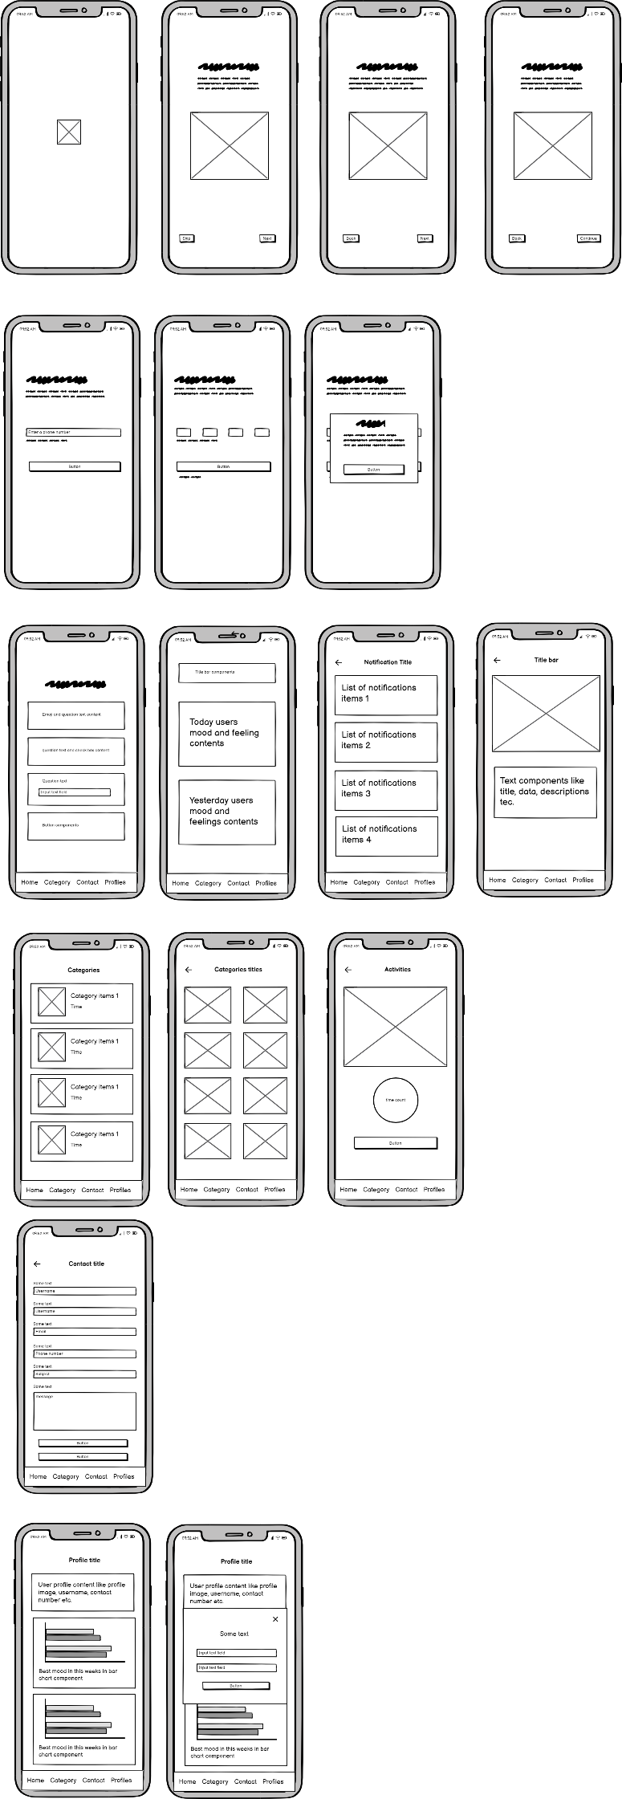

Figure 15: Wireframe walkthrough, login and home screen

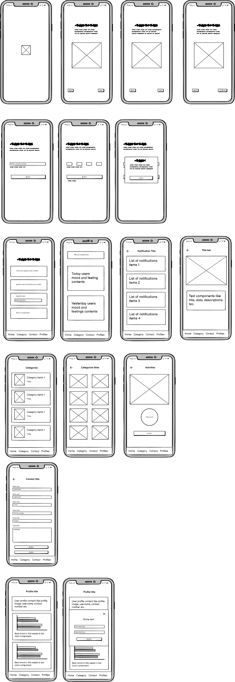

Figure 16: Wireframe category, contact and profile screen

## Low fidelity

An early-stage design concept's simplistic diagram is called a low-fidelity prototype. They are used by UX design teams to rapidly test concepts, spot holes and dangers, and eliminate ideas for products that don't appeal to consumers. Low-fidelity prototype, a crucial phase in the design thinking process, stimulates creativity and inspiration for user flow, content organization, and fundamental page layout. (community, 2024)

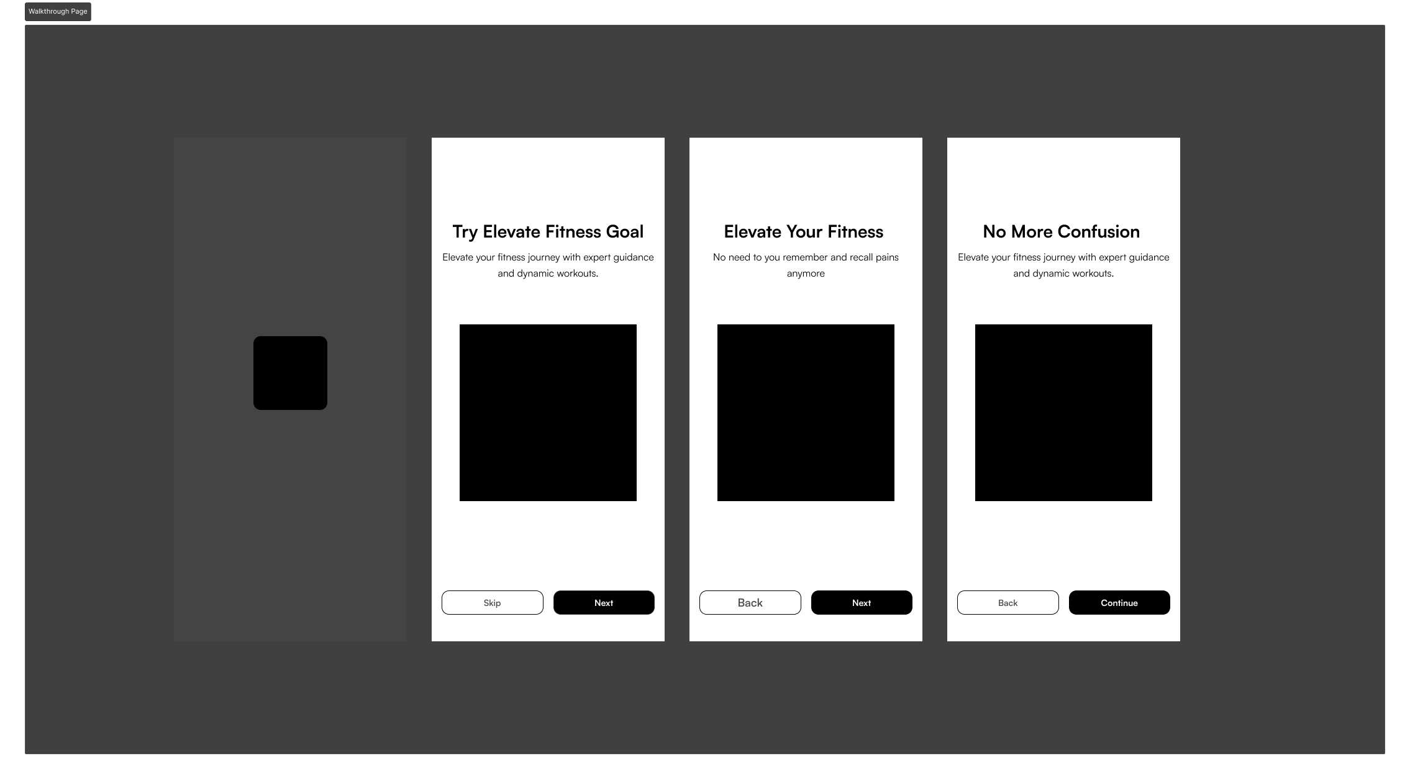

Figure 17: Low-Fidelity walkthrough screen

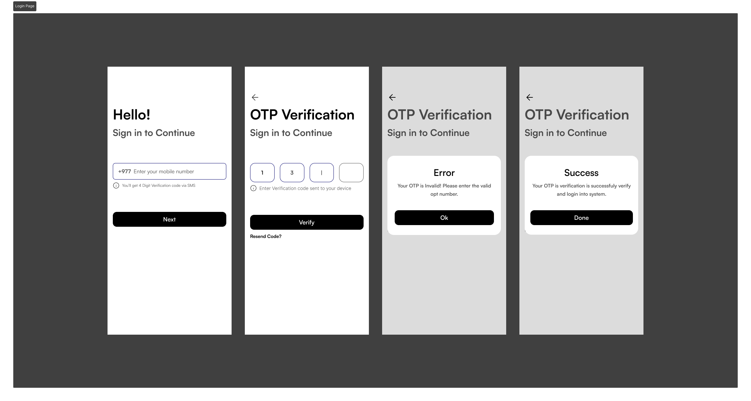

Figure 18: Low-Fidelity Login screen

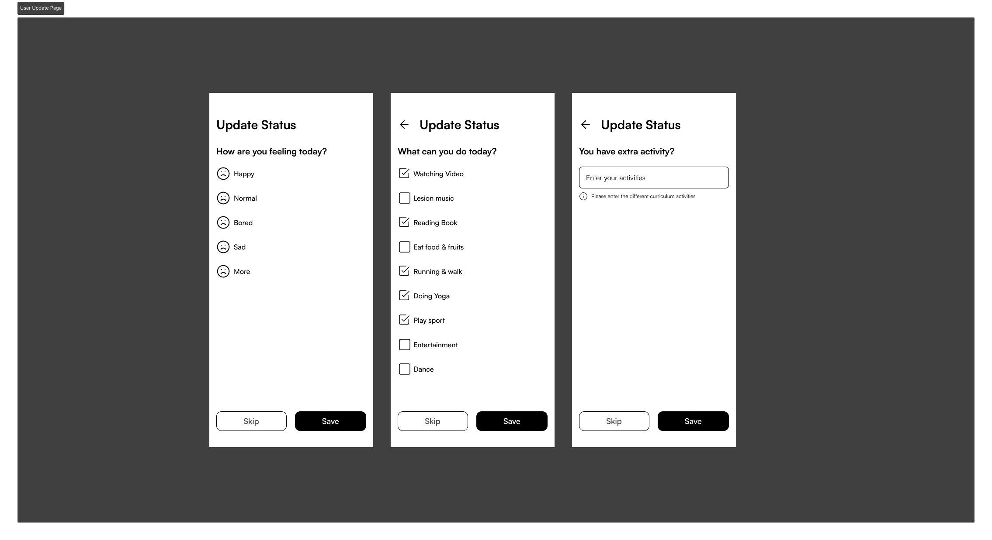

Figure 19: Low-Fidelity user update screen

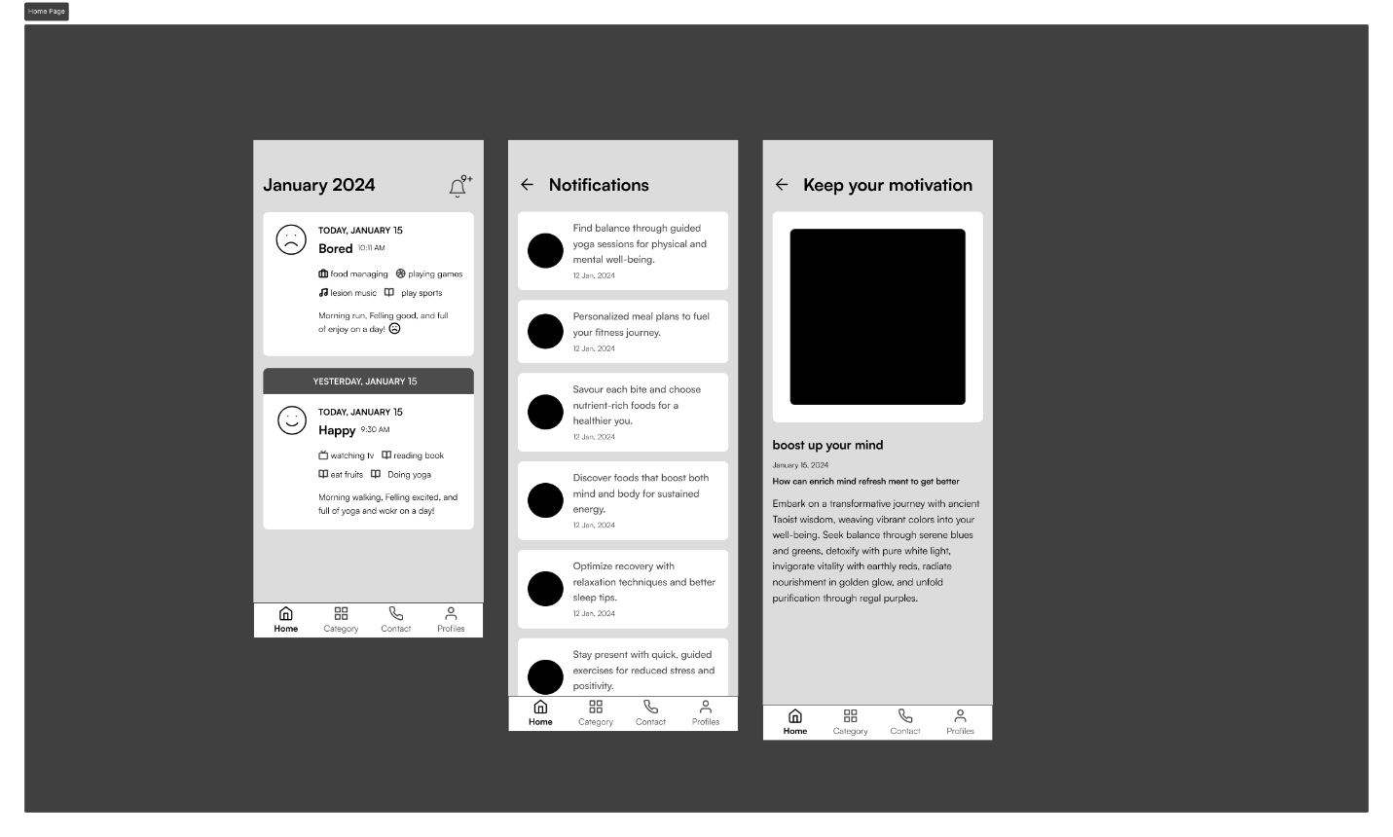

Figure 20: Low-fidelity home and notification screen

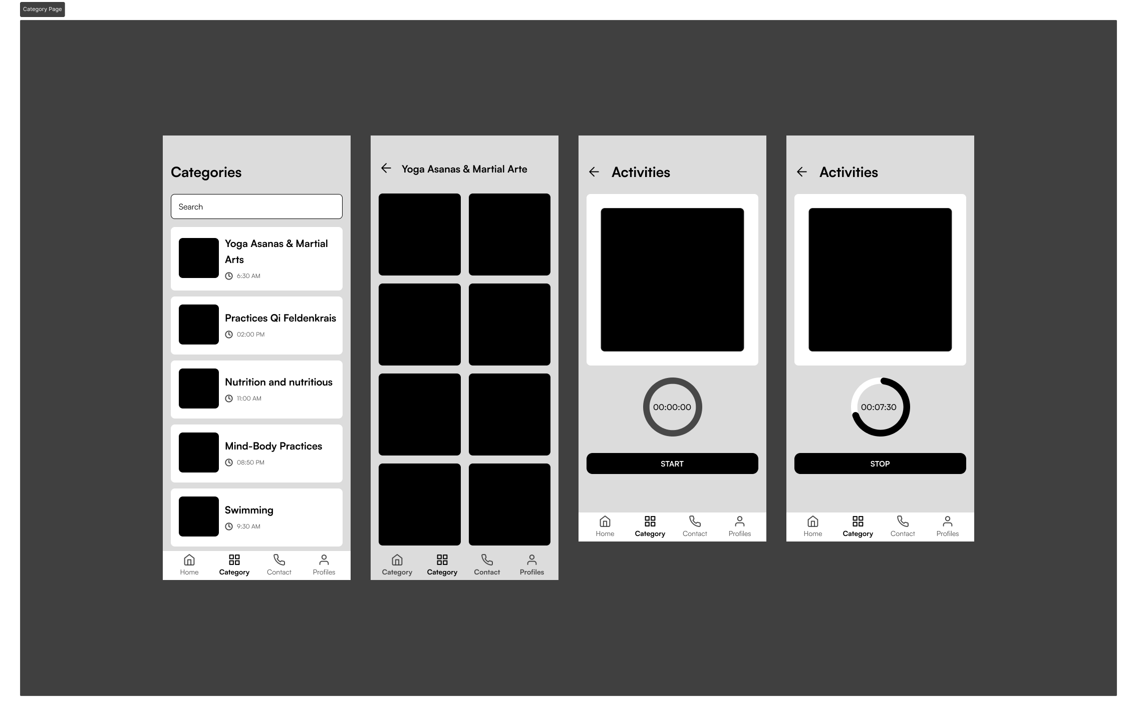

Figure 21: Low-Fidelity Category screen

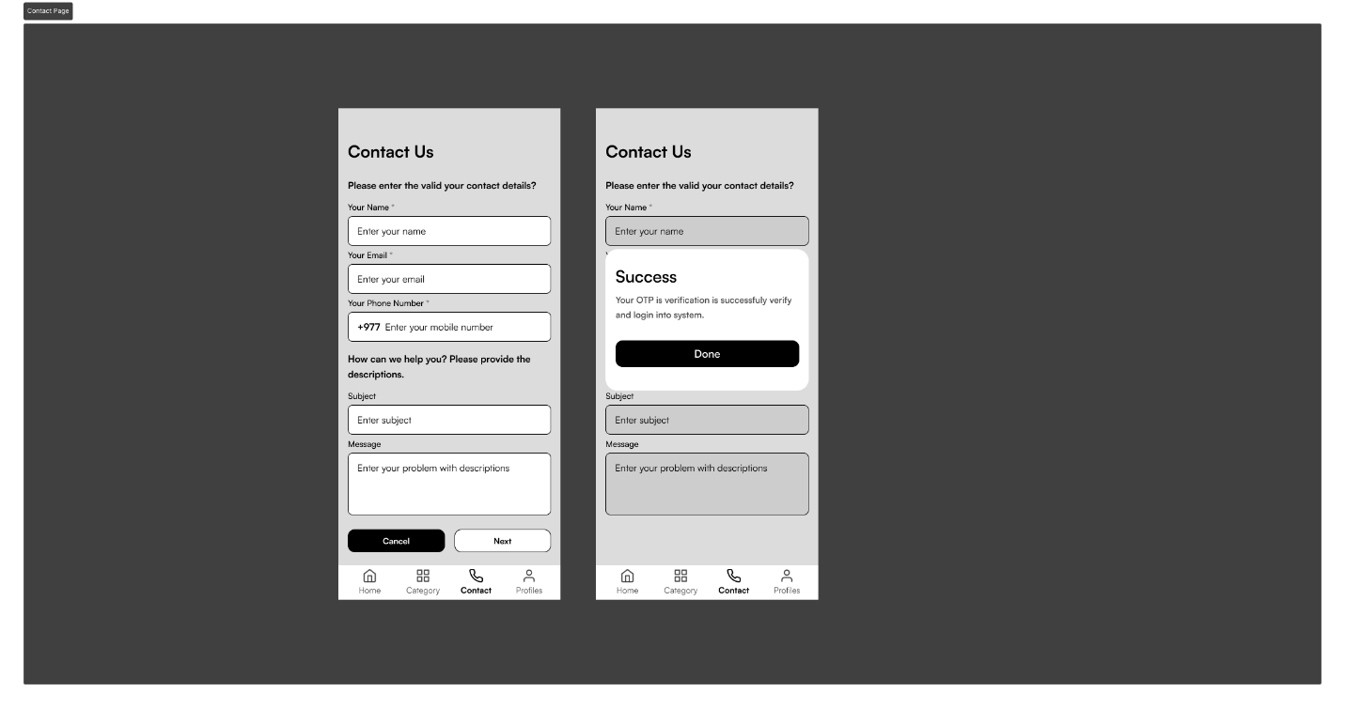

Figure 22: Low-Fidelity Contact screen

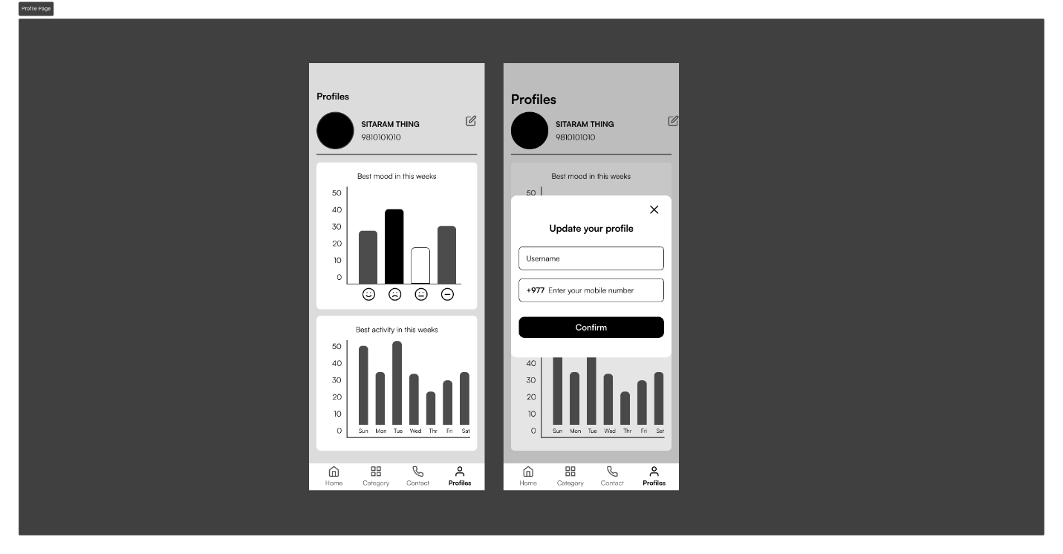

Figure 23: Low-Fidelity Profile screen

## High-fidelity

High-level fidelity in design is a crucial factor, in measuring the precision, meticulousness, and thoroughness integrated into a design prototype or representation. This metric evaluates how closely the design aligns with the ultimate product in terms of visual aesthetics, functionality, and user interactions. Often associated with sophisticated and polished representations, high-level fidelity aims to closely emulate the envisioned end product. Its significance varies throughout the design process, requiring a delicate balance based on the project's specific needs. Early stages may prioritize lower fidelity for rapid exploration, while high-level fidelity becomes more crucial as the design advances towards final implementation. This adaptability underscores that the emphasis on fidelity levels is not fixed, ensuring optimal design strategies tailored to the evolving requirements.

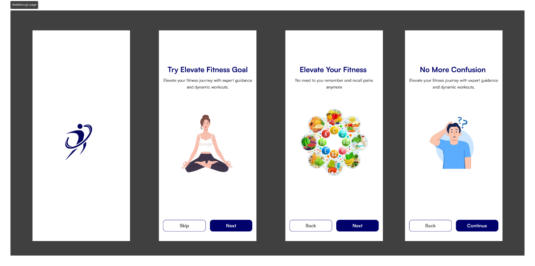

Figure 24: High-fidelity walkthrough screen

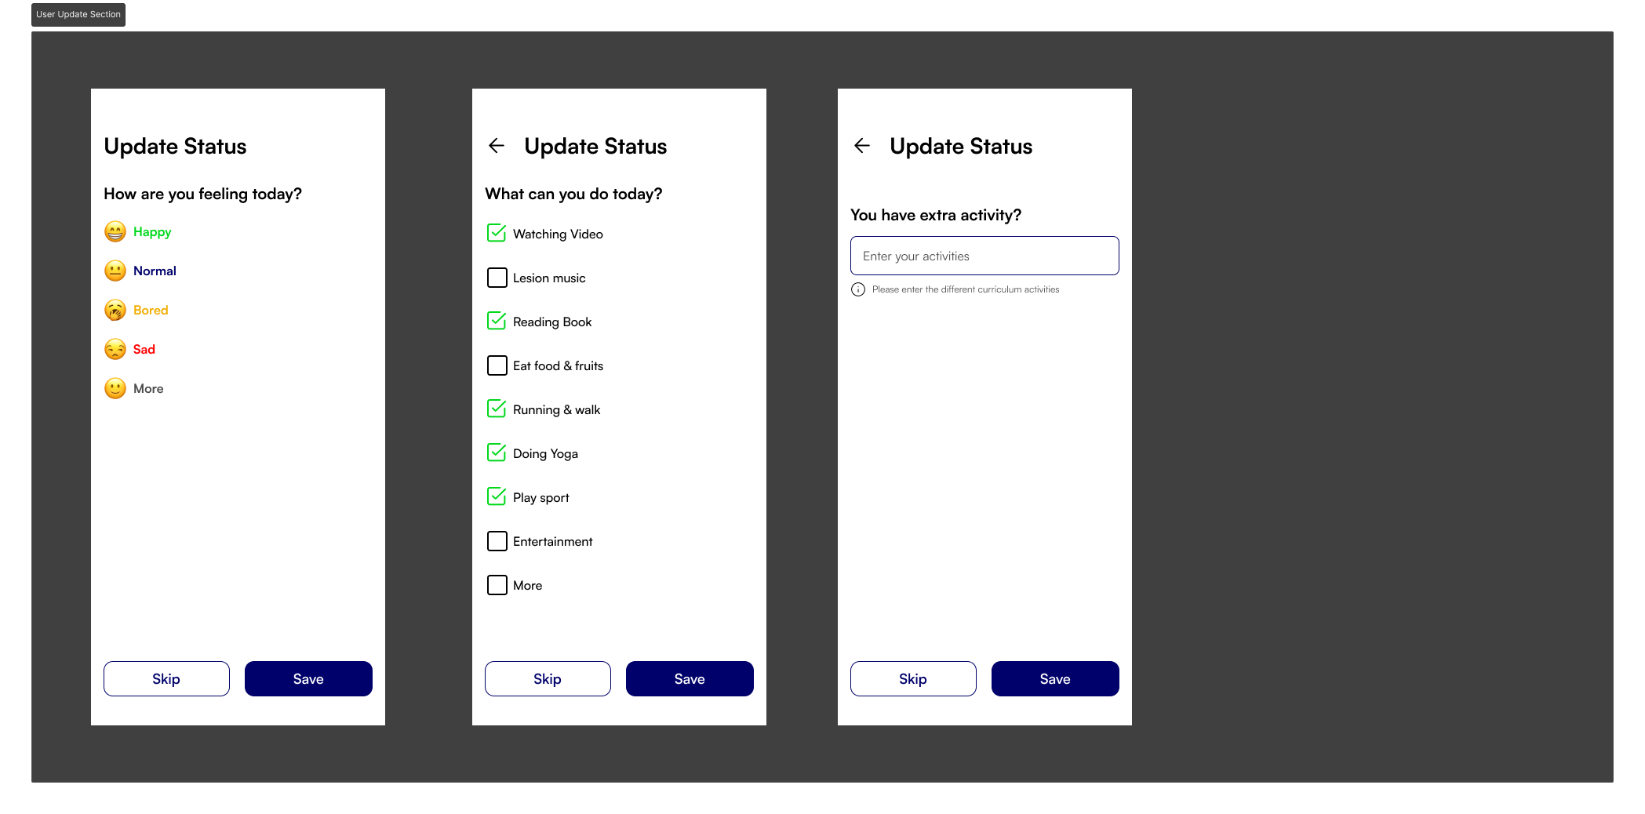

Figure 25: High-fidelity user update screen

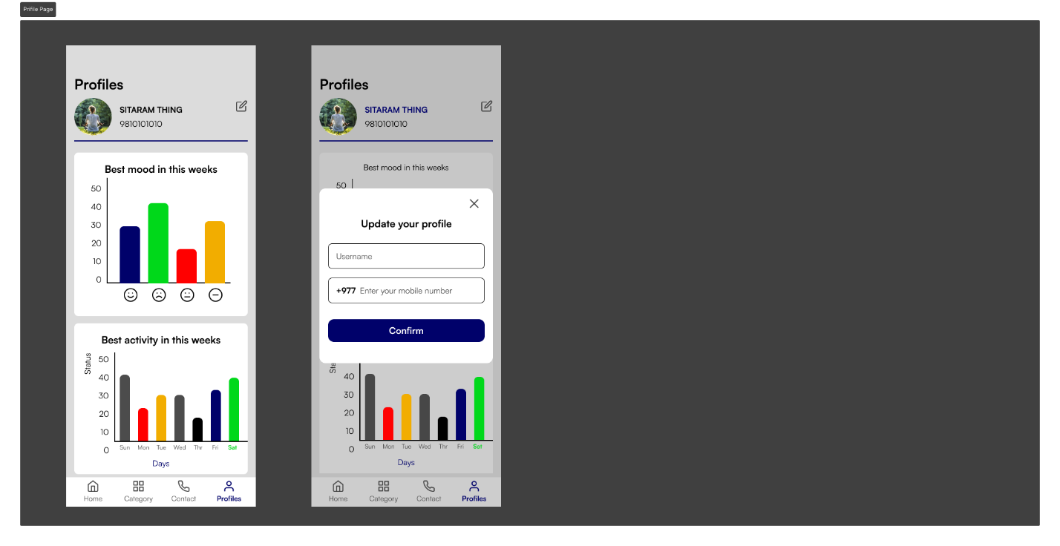

Figure 26: High-Fidelity profile screen

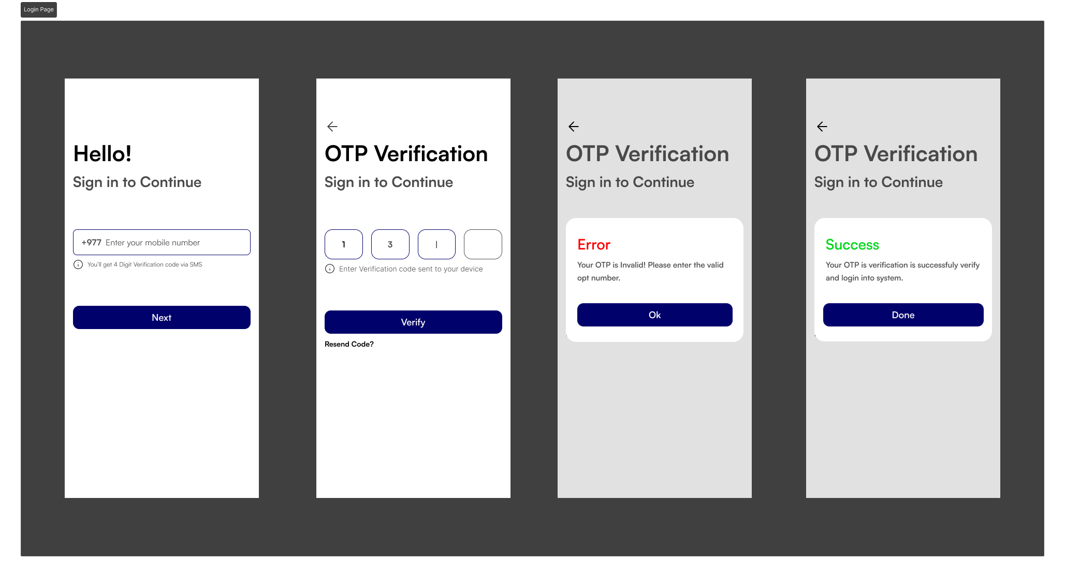

Figure 27: High-Fidelity login screen

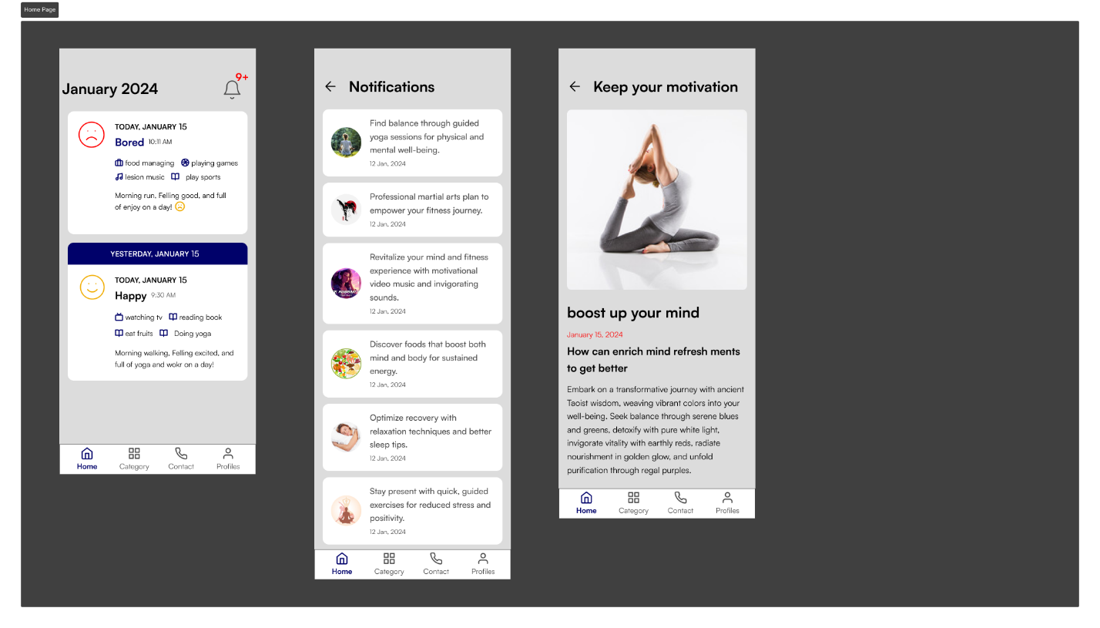

Figure 28: High-fidelity home & notification screen

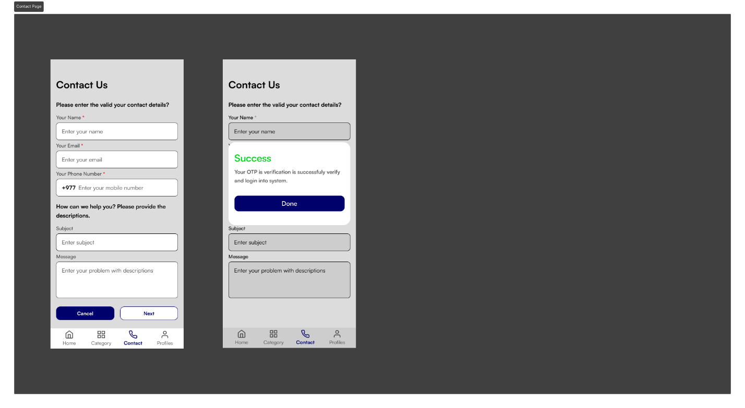

Figure 29: High-Fidelity contact screen

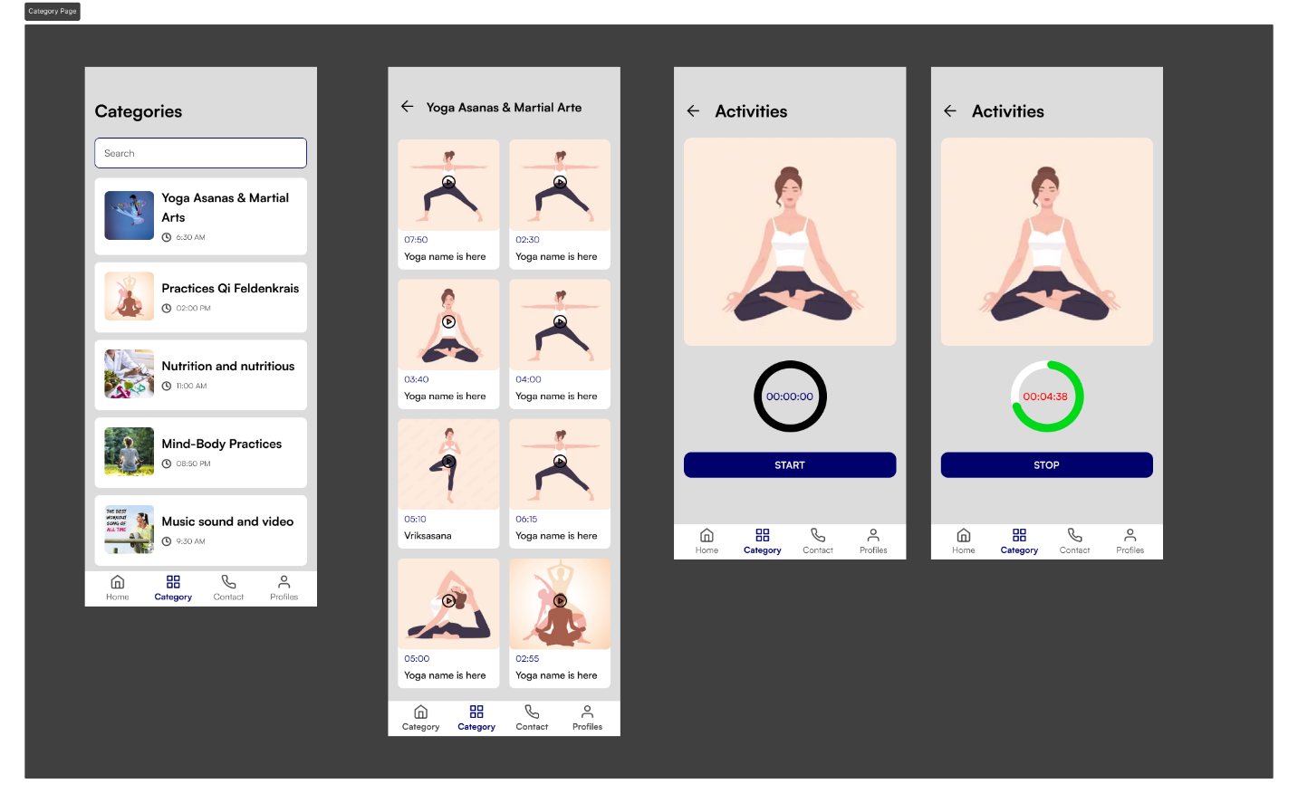

Figure 30: High-Fidelity category screen

# Test

## UI Design Testing

|  |  |
| --- | --- |
| **Test No** | 1 |
| **Objective** | To assess the UI design transition from wireframe and low fidelity to high fidelity, incorporating the primary dark blue color and secondary colors (green, red, yellow, dark gray, black, and white), using the Satoshi variable typeface, and differentiating theming styles. |
| **Action** | * Apply bold and black styling to main headings. * Set subheadings to half the size of main headings. * Use a normal-sized font for paragraphs, ensuring clarity. * Align all text to the left side for consistency. * Utilize attractive colors for text and backgrounds. * Ensure icons are easily recognizable and enhance user navigation. |
| **Expected Result** | The UI should present an aesthetically pleasing and user-friendly interface, with improved visuals and minimal user effort. |
| **Actual Result** | The UI design successfully meets the expectations, with well-defined headings, clear paragraphs, consistent left-side alignment, attractive color usage, and easily recognizable icons. |
| **Remark** | The UI design successfully meets the expectations, with well-defined headings, clear paragraphs, consistent left-side alignment, attractive color usage, and easily recognizable icons. |

Table 1: UI testing

## UX Testing

|  |  |
| --- | --- |
| **Test No** | 1 |
| **Objective** | Evaluate the overall user experience (UX) of the fitness app design, focusing on usability, navigation, and user satisfaction. |
| **Action** | * Assess how easily users can accomplish these tasks and identify any usability issues. * Check the accessibility of navigation elements. * Evaluate how users interact with interactive elements, such as buttons, forms, and feedback messages. * Use surveys or interviews to understand user satisfaction, preferences, and areas for improvement. * Check if interactive elements provide clear feedback and guidance to users. |
| **Expected Result** | The UX testing should reveal a user-friendly interface with intuitive navigation, positive user feedback, and a seamless overall experience. |
| **Actual Result** | The UX testing indicates that the fitness app design meets user expectations, providing a user-friendly experience with logical navigation and positive feedback. |
| **Remark** | The UX testing is successful, indicating that the fitness app design not only meets usability standards but also delivers a positive and satisfying experience for users. Any identified issues are addressed, contributing to the overall enhancement of the user journey. |

Table 2: UX testing

## Functional Testing

|  |  |
| --- | --- |
| **Test No** | 1 |
| **Objective** | Conduct functional testing on the fitness app to ensure all features and functionalities work as intended, providing a seamless user experience. |
| **Action** | * Test each core feature of the fitness app individually. * The system can best performance without lack. * Verify that the app provides appropriate feedback for valid and invalid inputs. * Ensure that calculations, such as calorie tracking and progress metrics, are precise. * Verify the integration of external components, such as fitness trackers or wearables. * Evaluate loading times, response times, and overall responsiveness. |
| **Expected Result** | The UI should exhibit optimal performance, responding seamlessly to user interactions, loading quickly, and maintaining design fidelity between Figma and the actual interface. |
| **Actual Result** | The UI design successfully achieves optimal performance, providing a smooth and responsive user experience. Figma design elements align consistently with the implemented UI. |
| **Remark** | The UI performance testing and Figma design alignment are successful, ensuring that the fitness app delivers a high-quality and lag-free experience for users. Any identified issues are addressed to maintain optimal performance. |

Table 3: Functional test

# Conclusion

The "FitGuide Pro" fitness app, meticulously designed on Figma and FigJam, embodies a comprehensive and user-centric solution dedicated to promoting holistic well-being. Commencing with extensive research into physical fitness, involving user interviews, empathy mapping, and user persona development, the project prioritized understanding user needs and preferences. The subsequent design process systematically advanced through wireframing, low-fidelity prototypes, and high-fidelity prototypes, with each stage thoroughly tested and refined based on valuable user feedback. Real-time collaboration features in FigJam facilitated effective teamwork and seamless brainstorming sessions during the design phase.

Beyond offering a visually appealing and user-friendly interface, the fitness application integrates a wealth of content covering fitness knowledge, physical exercises, mental well-being practices, and educational resources. Guided by a user journey map, it ensures a cohesive and intuitive user experience from the initial research phase to the final prototype testing. Embodying a user-centric design philosophy, the app prioritizes user needs and preferences, guiding users not only through their physical fitness journey but also nurturing their mental well-being. This commitment promotes a holistic and sustainable approach to a healthier lifestyle, providing users with an accessible and informative gateway to the world of fitness.

The app's development began with a deep dive into research, user interviews, empathy mapping, and user persona development to understand and prioritize user needs. The user-centric design process then unfolded through wireframing, low-fidelity and high-fidelity prototypes, allowing for rigorous testing and refinement. With an intuitive interface, the application delivers valuable content encompassing fitness knowledge, physical exercises, mental well-being practices, and educational resources. Supported by a user journey map, the app ensures a cohesive and enjoyable experience, fostering a holistic approach to health and encouraging sustainable lifestyle changes. The FitGuide Pro fitness app gives a successful fusion of thoughtful design, user engagement, and a commitment to enhancing users' overall well-being.

# References

community, L. F. (2024, 01 16). *Low Fedality*. Retrieved from Resource library: https://www.figma.com/resource-library/low-fidelity-prototyping/

Edwards, S. (2024, 01 17). *User Persona’s, a Quick Introduction*. Retrieved from Medium: https://medium.com/@sarah.edwards/user-personas-a-quick-introduction-ee44cbcac176

Finder, Y. (2024, 01 17). *Description of Yoga*. Retrieved from Yoga Finder: https://www.yogajournal.com/pose-finder/pose-finder/

Group, N. N. (2024, 01 17). *Empathy Mapping*. Retrieved from Nielsen Norman Group: https://www.nngroup.com/articles/empathy-mapping/

Hunt, C. (2024, 01 17). *Color selection*. Retrieved from Color Palettes for Designers and Artists: https://colorhunt.co/

Johansson, K. E. (2024, 01 16). *Embark on a Journey to The Wealth of Well-being*. Retrieved from The Wealth of Well-being: https://medium.com/illumination/embark-on-a-journey-to-the-wealth-of-well-being-643dcf7b8e2d

Pell, A. (2024, 01 15). *User Journey Map*. Retrieved from Zapire: https://zapier.com/blog/customer-journey-mapping/

Sevareid, T. W. (2024, 01 17). *The Color Palettes of Mental Healthcare UI*. Retrieved from Fuzzy math: https://fuzzymath.com/blog/the-color-palettes-of-mental-healthcare-ui/

Studios, B. (2024, 01 15). *Wireframe*. Retrieved from Balsmiq: https://balsamiq.com/learn/articles/what-are-wireframes/

# Appendix

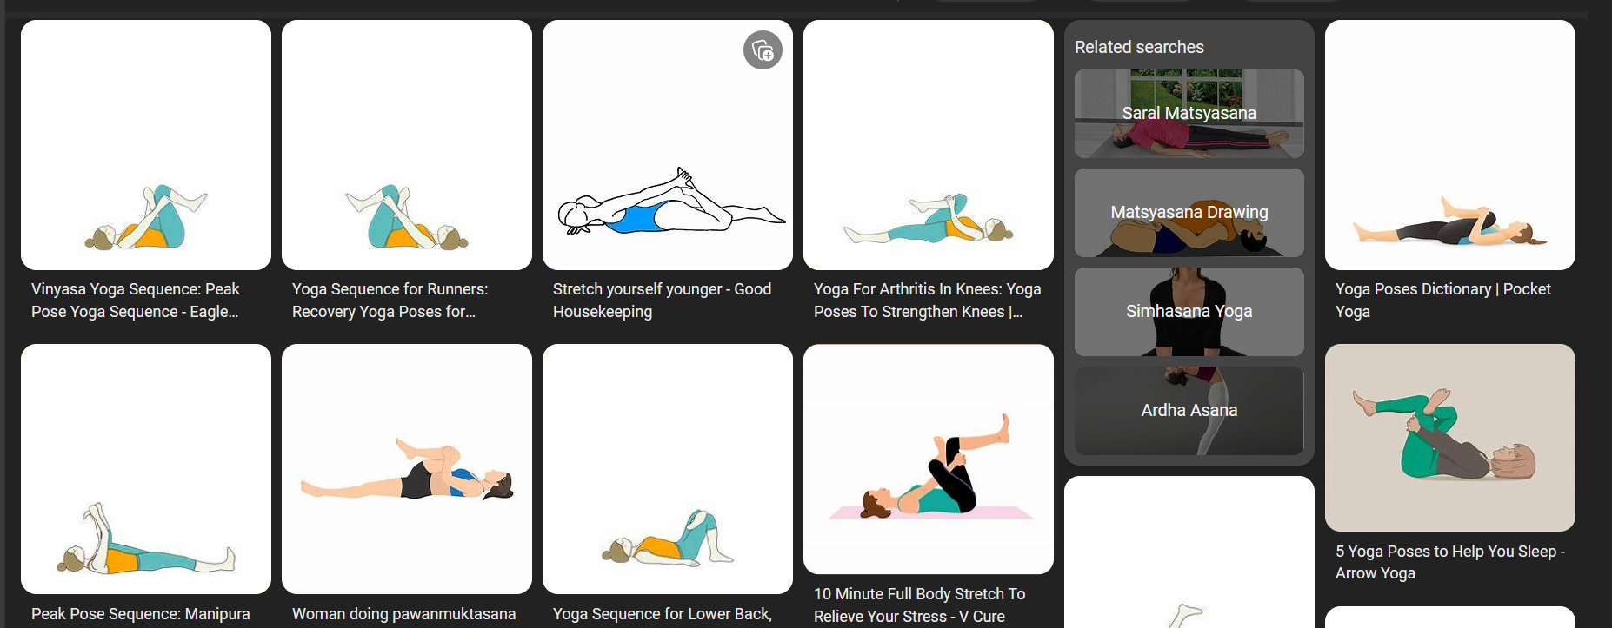

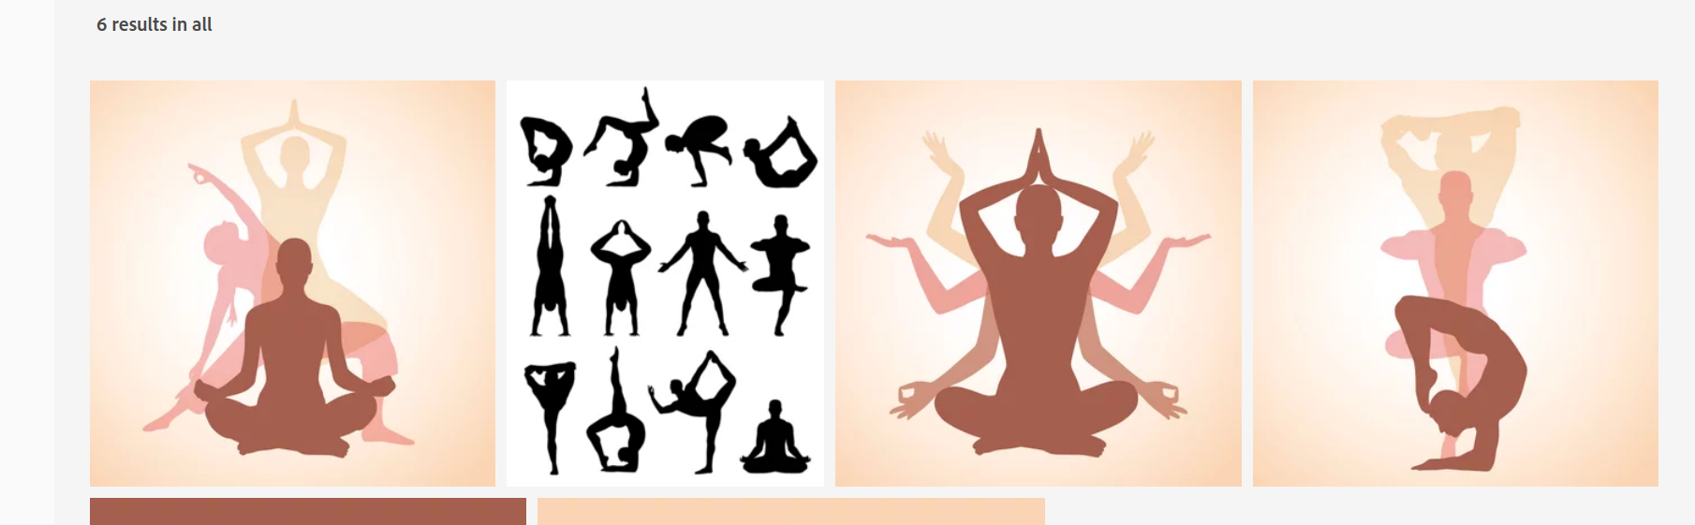

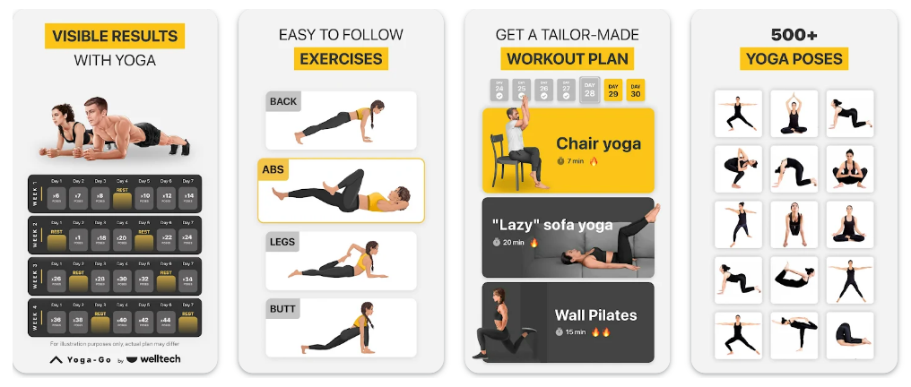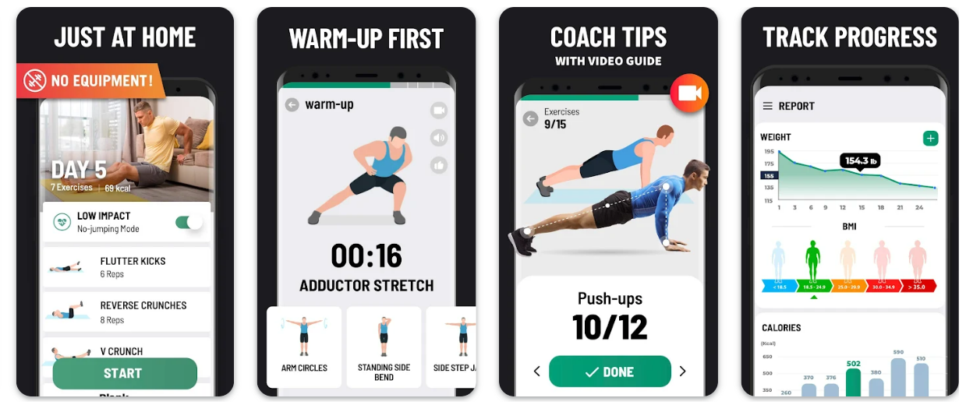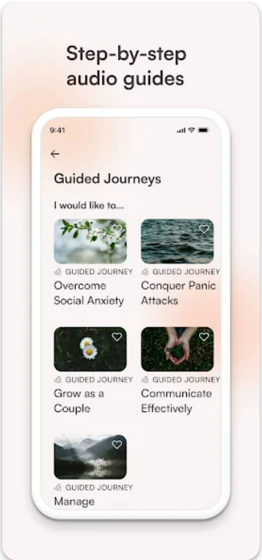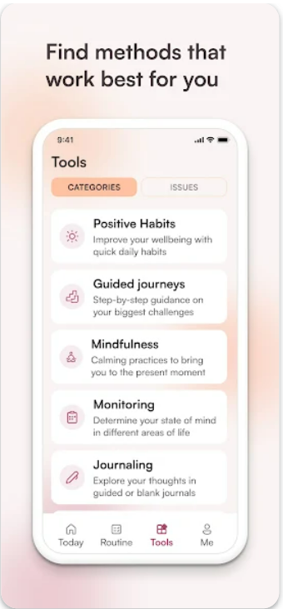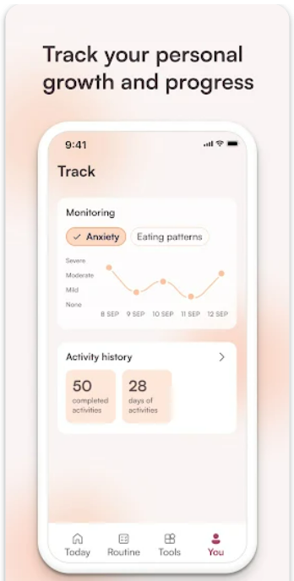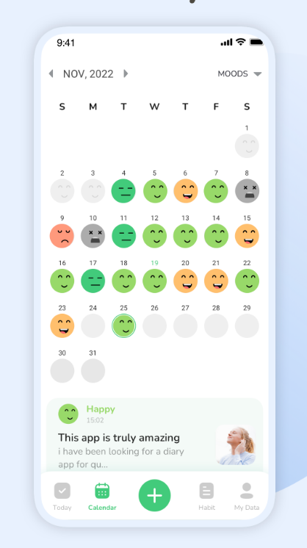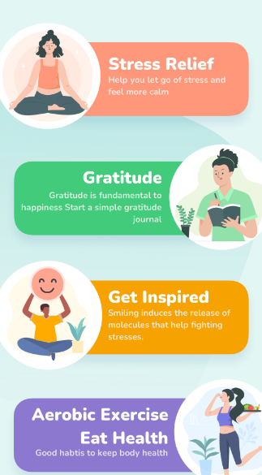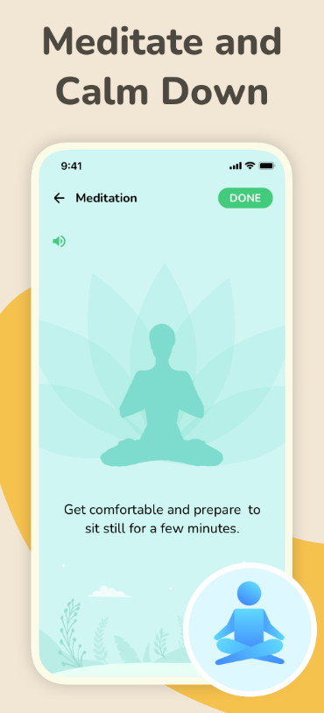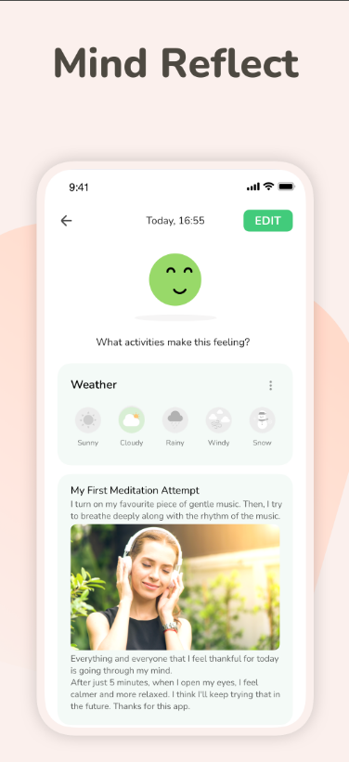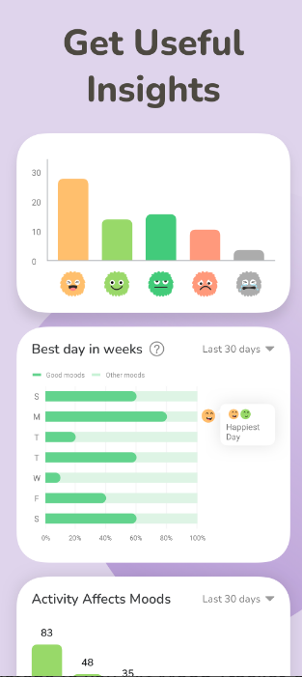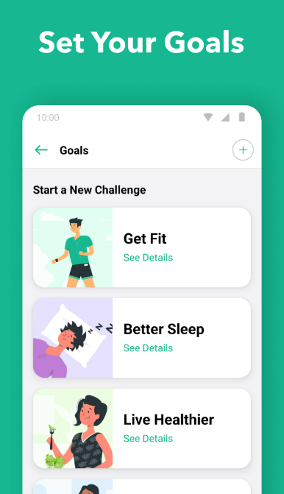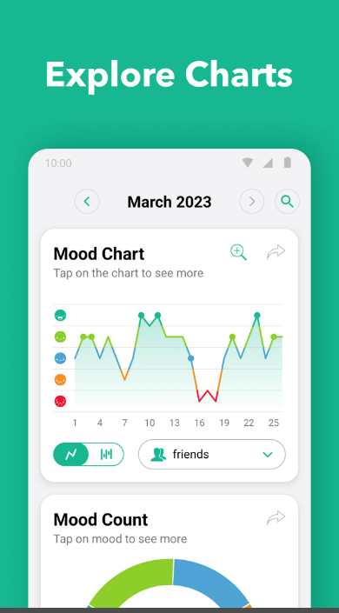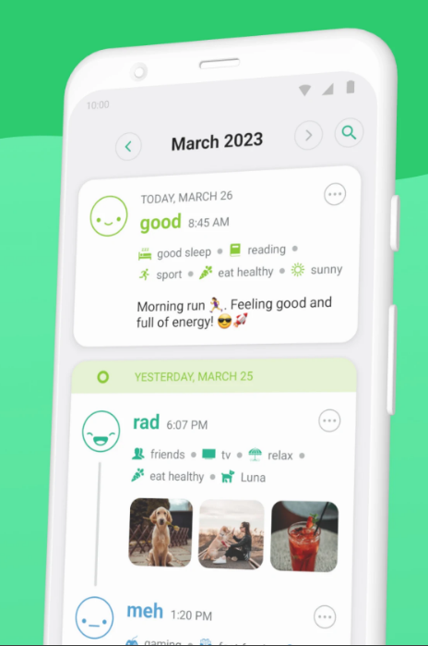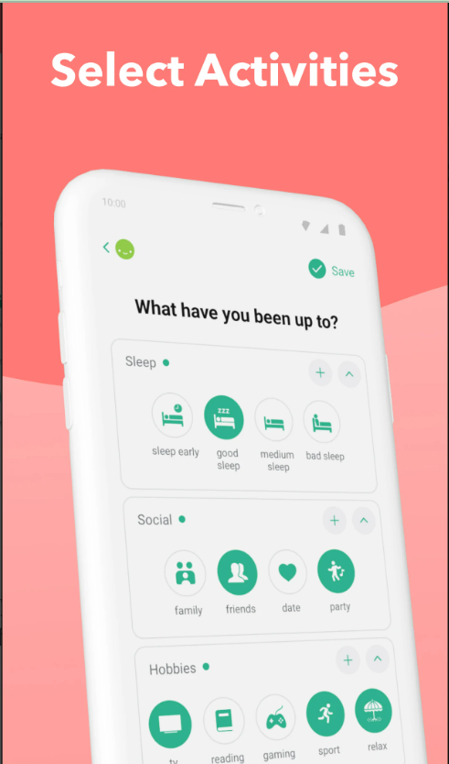

Go back to same page.